ADVANCED DATABASE TECHNIQUES PRACTICAL

# Practical No. 1

Create different types that include attributes and methods. Define tables for these types by adding a sufficient number of tuples. Demonstrate insert, update and delete operations on these tables. Execute queries on them.

## Solution :

**Step 1 :** Start [www.oracle.com](http://www.oracle.com/) Sign in 0R Sign up

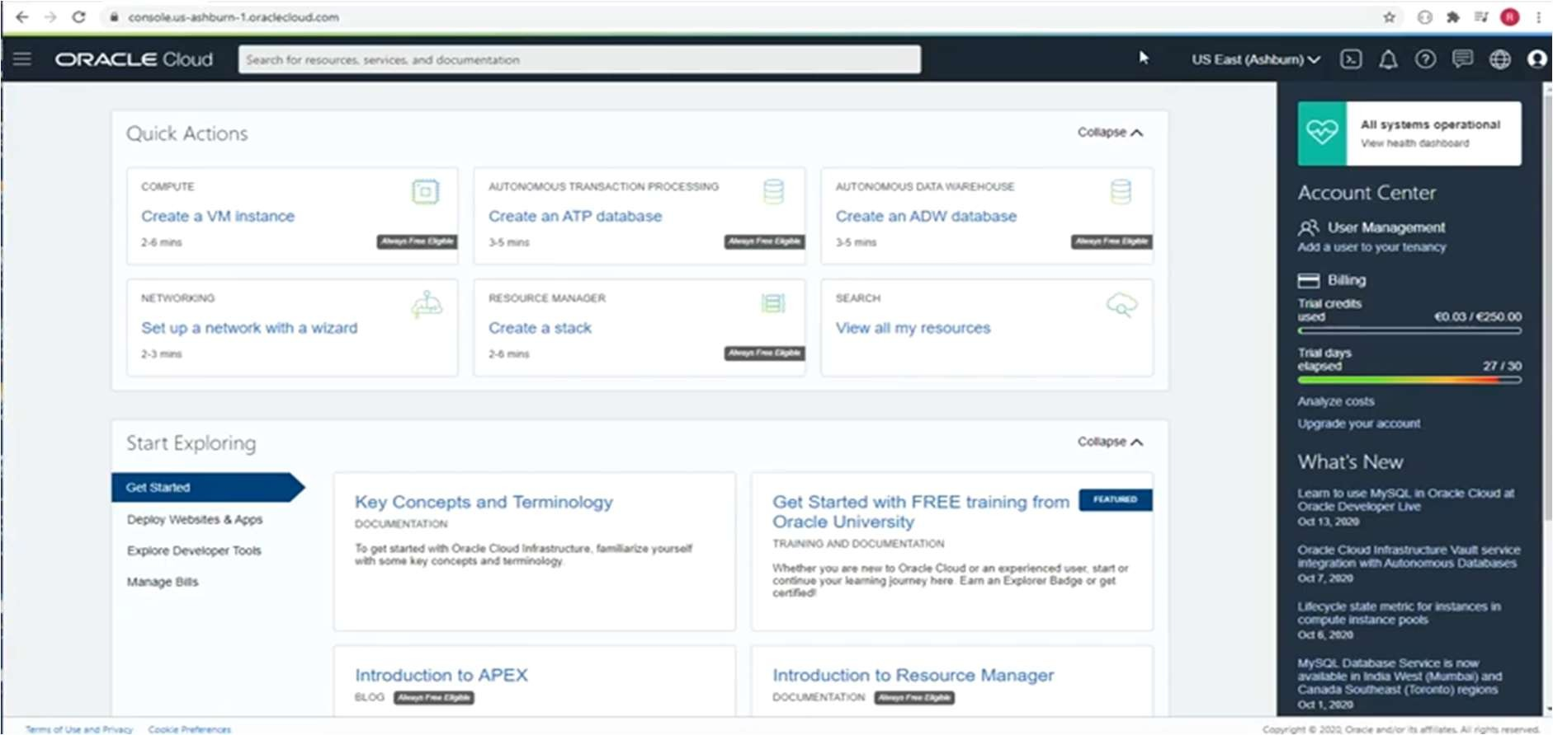

**Step 2** : In search box, type Nosql and in serives select Nosql database

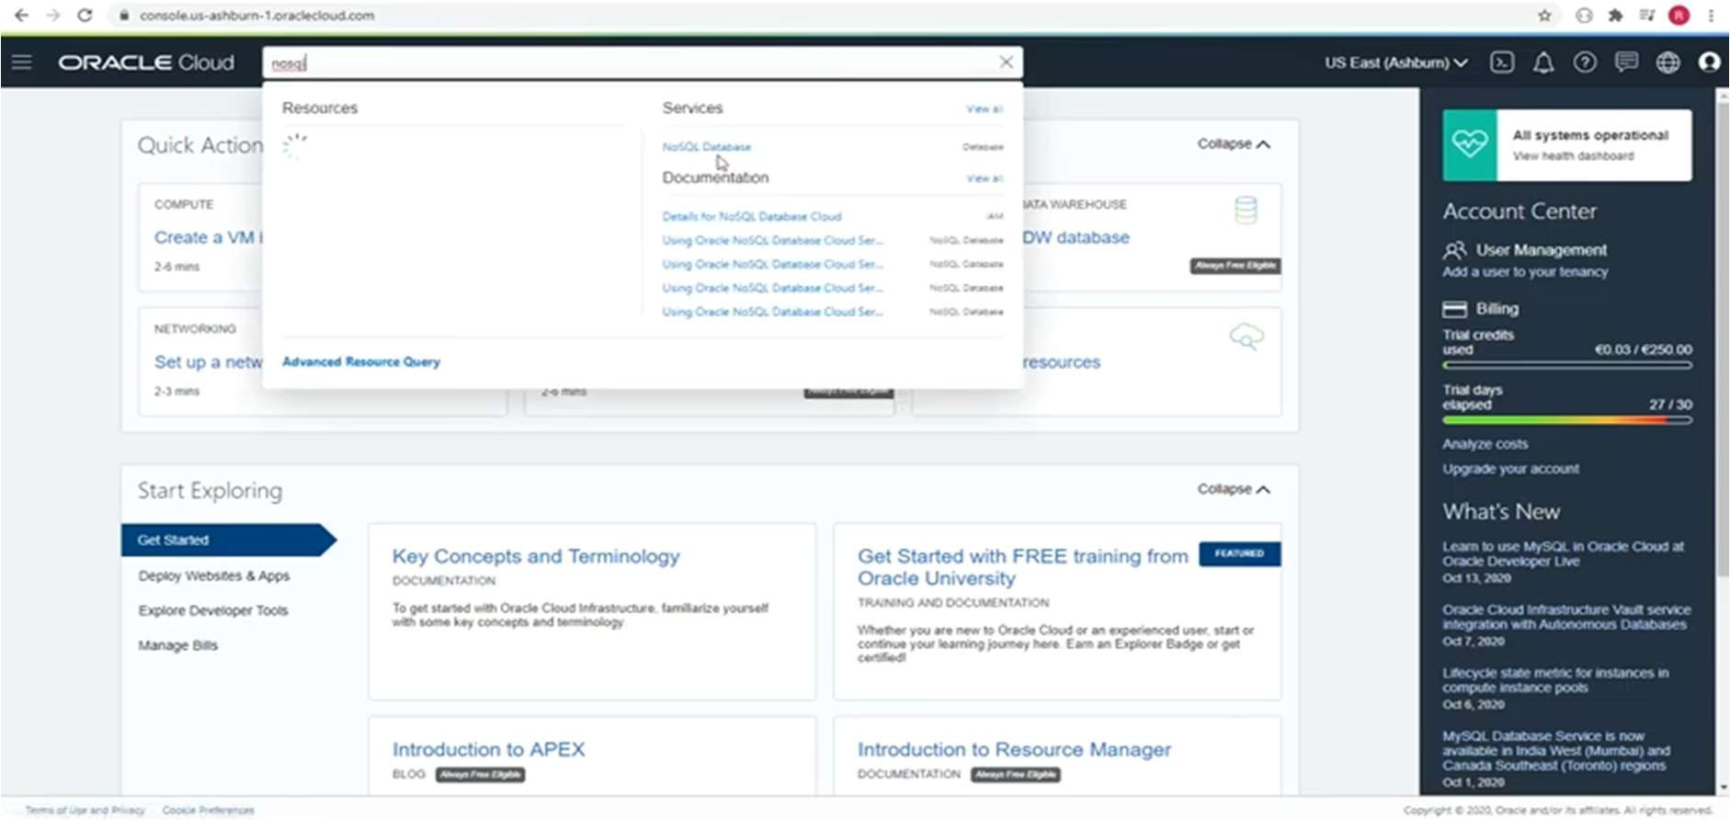

**Step 3** : Click on Create Table.

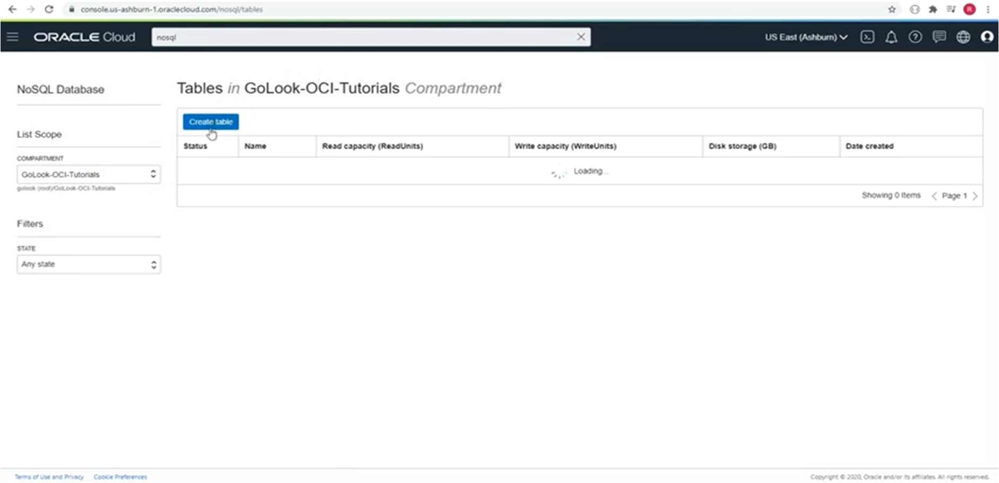

**Step 4** : Mention Name of Table and create columns as required.

Type name of columns and their data types in respective box.

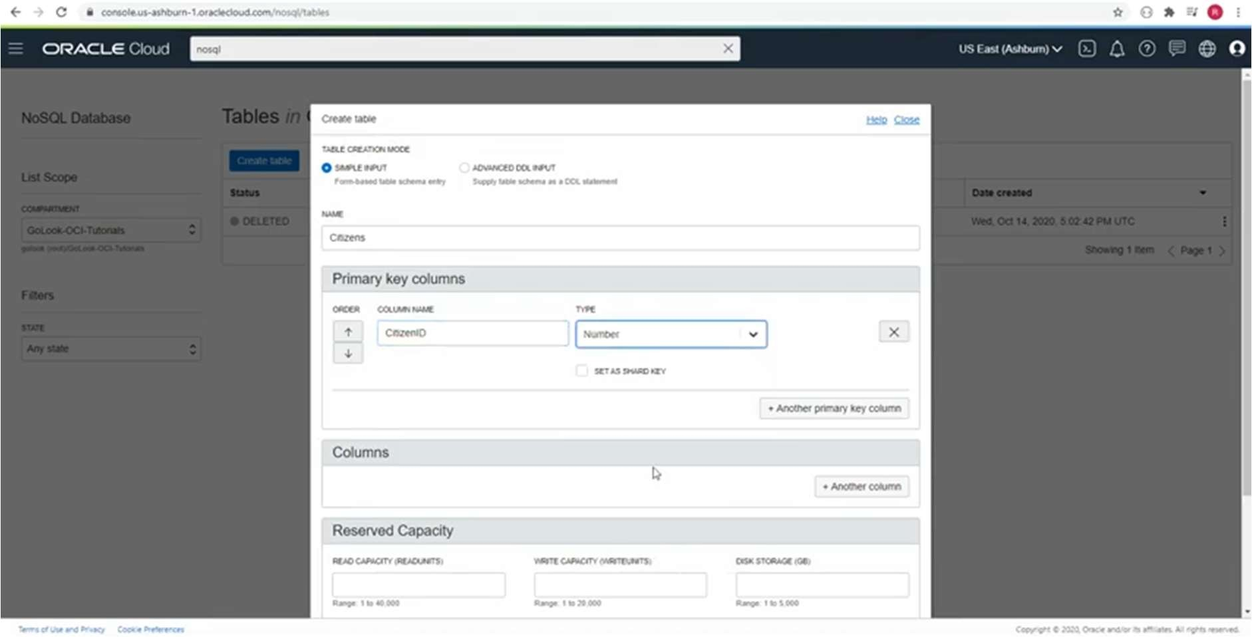

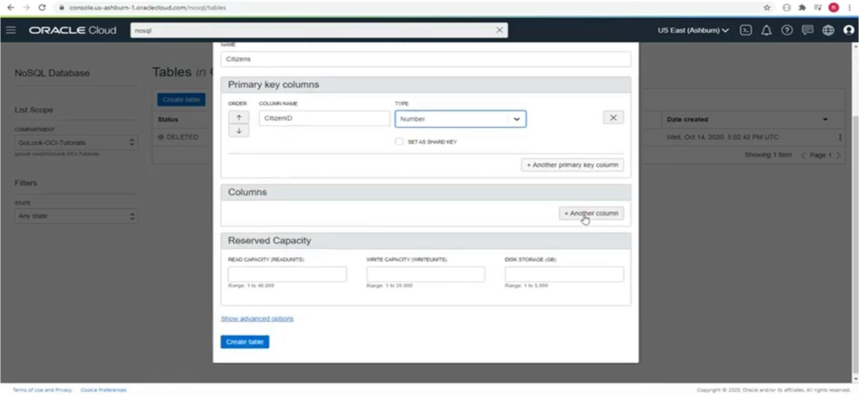

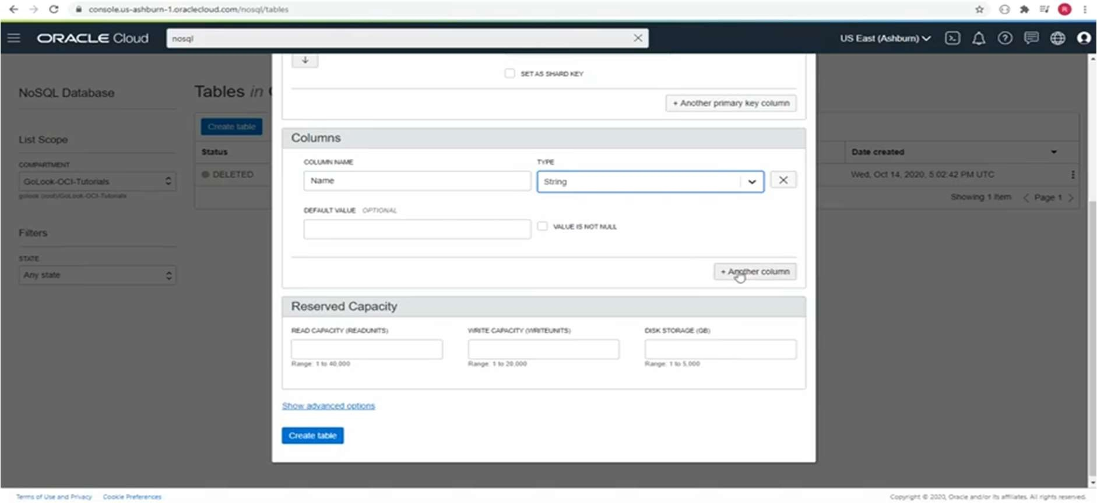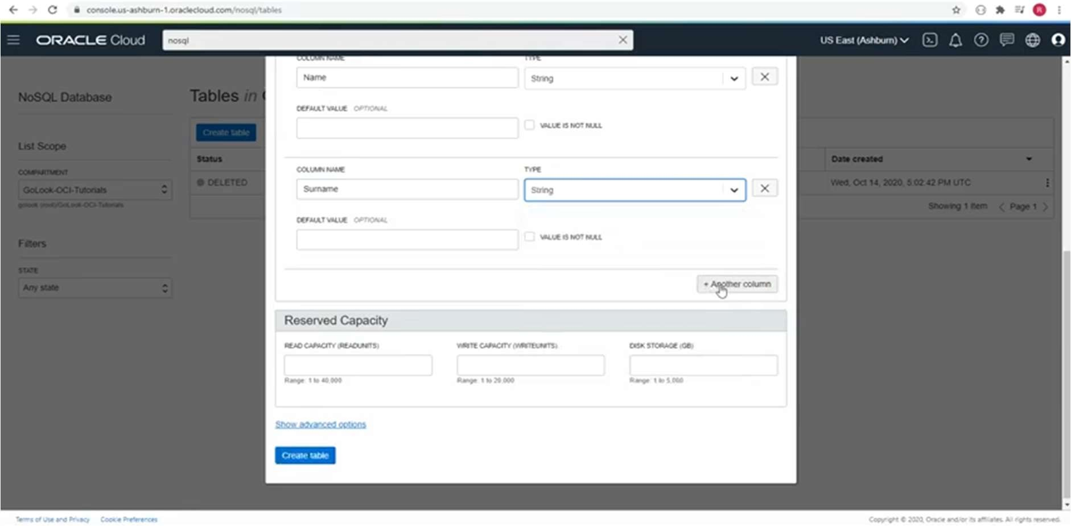

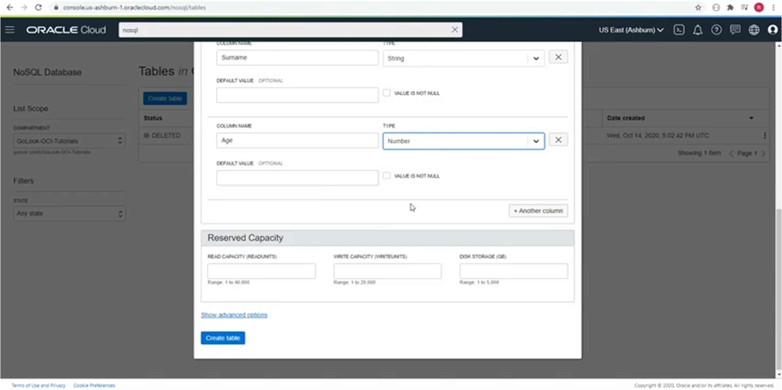

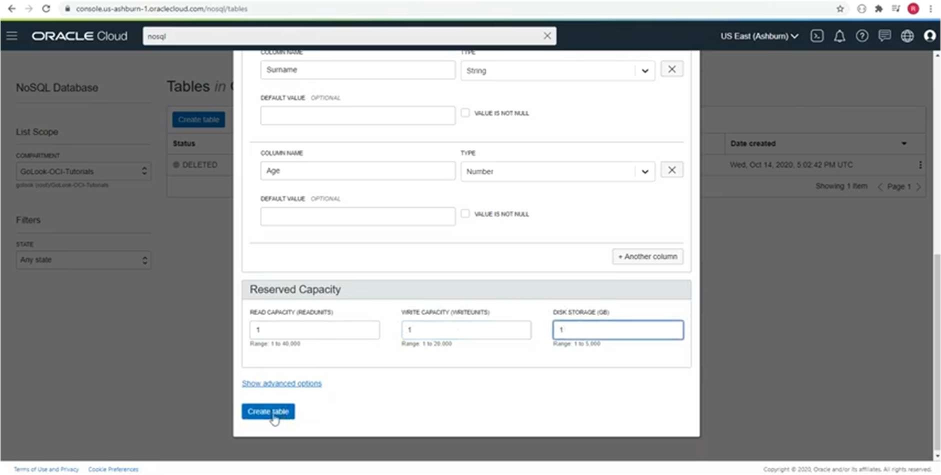

Table is created.

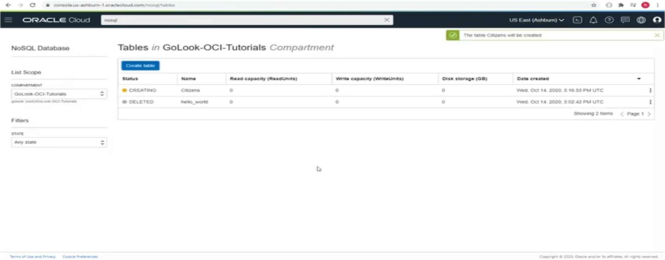

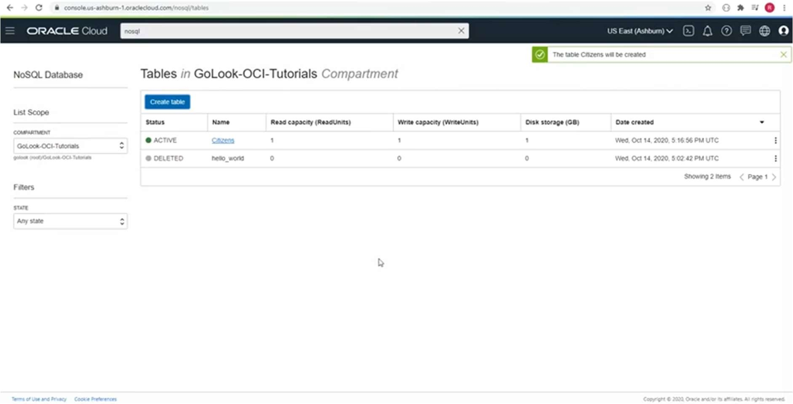

**Step 5** : Click on Table Name.

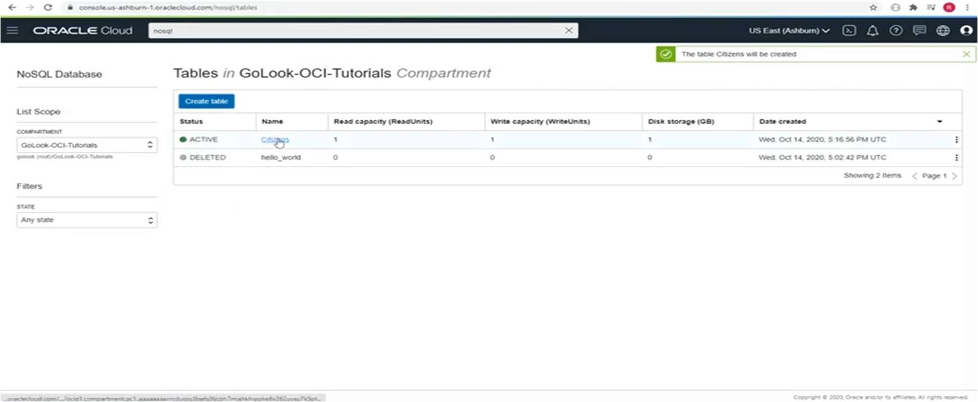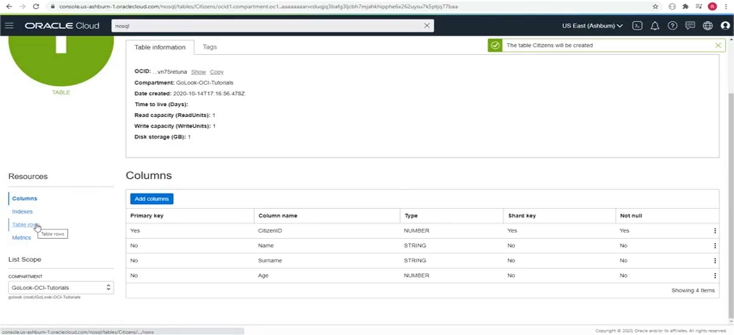

**Step 6** : To insert rows , click on Insert Row from above option.

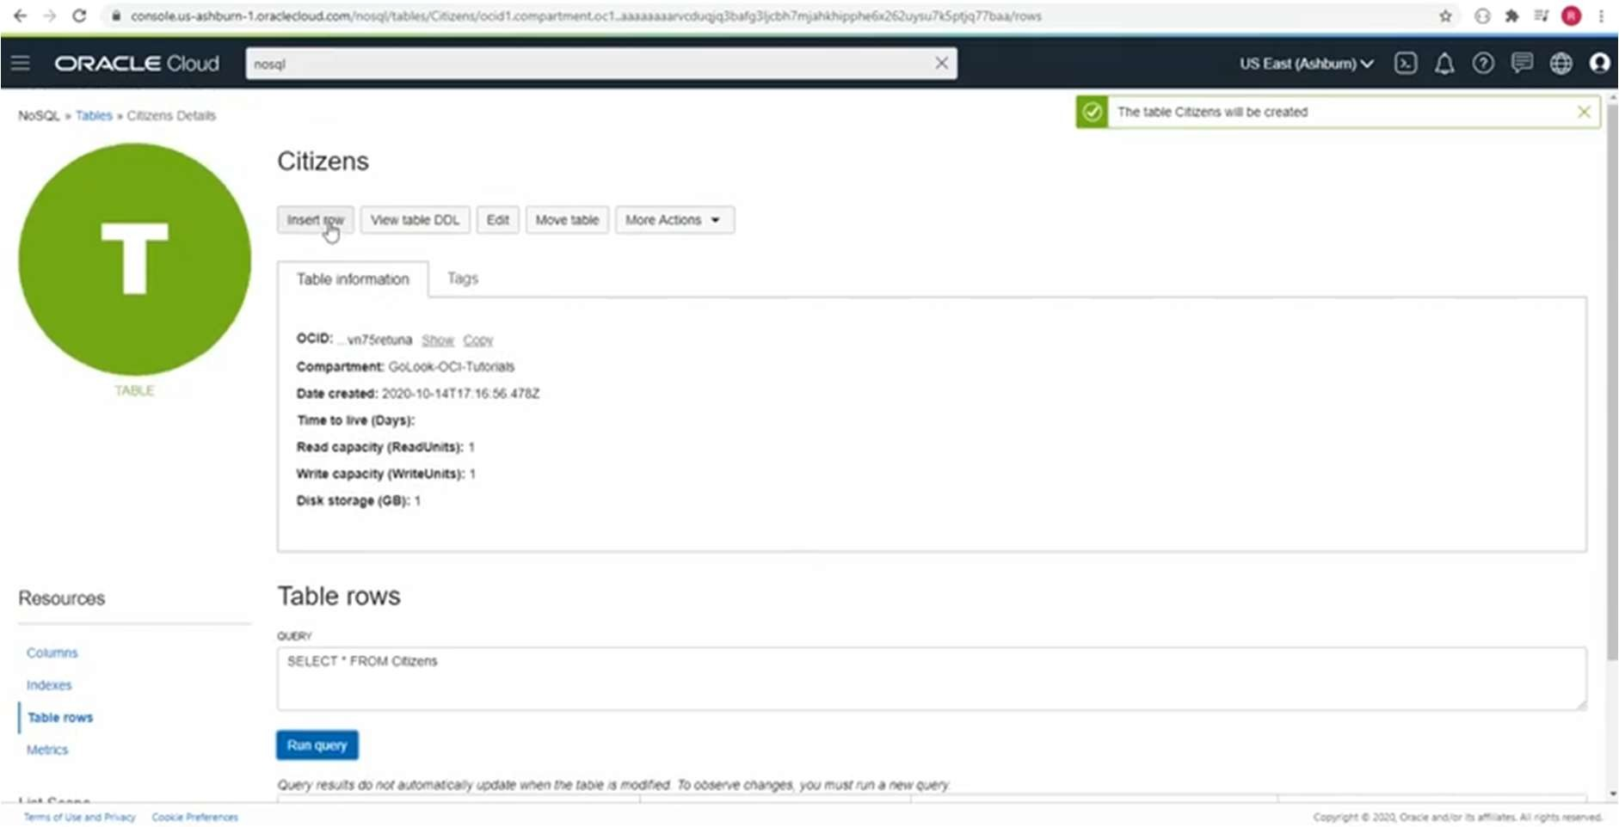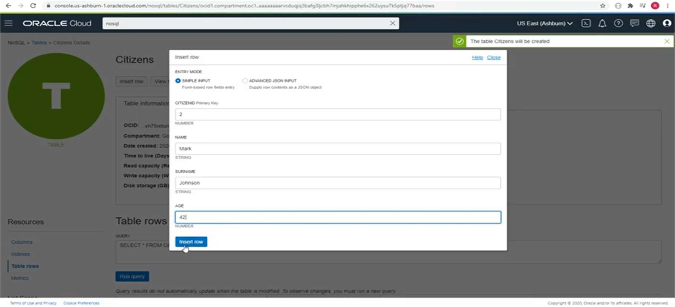

**Step 7** : Run Queries.

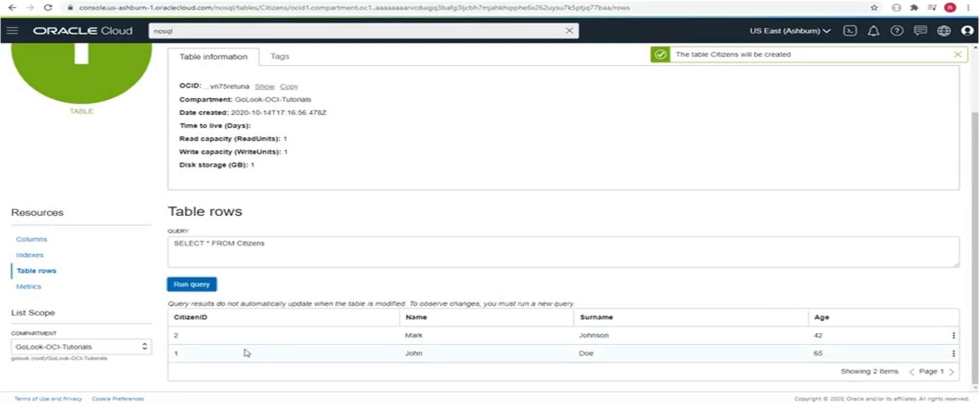

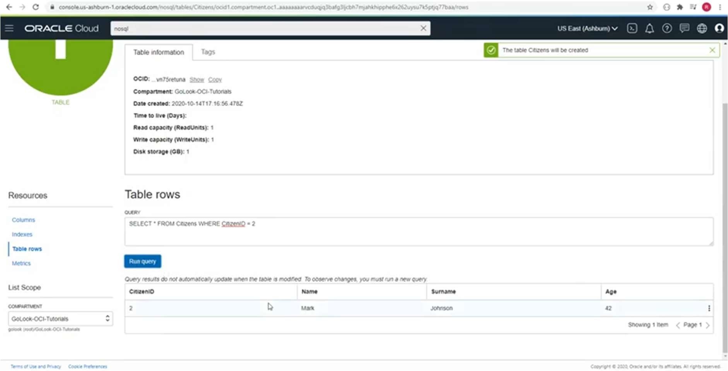

**Step 8** : To Update Table

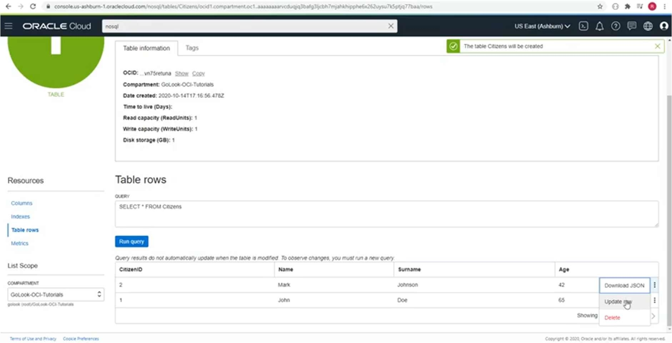

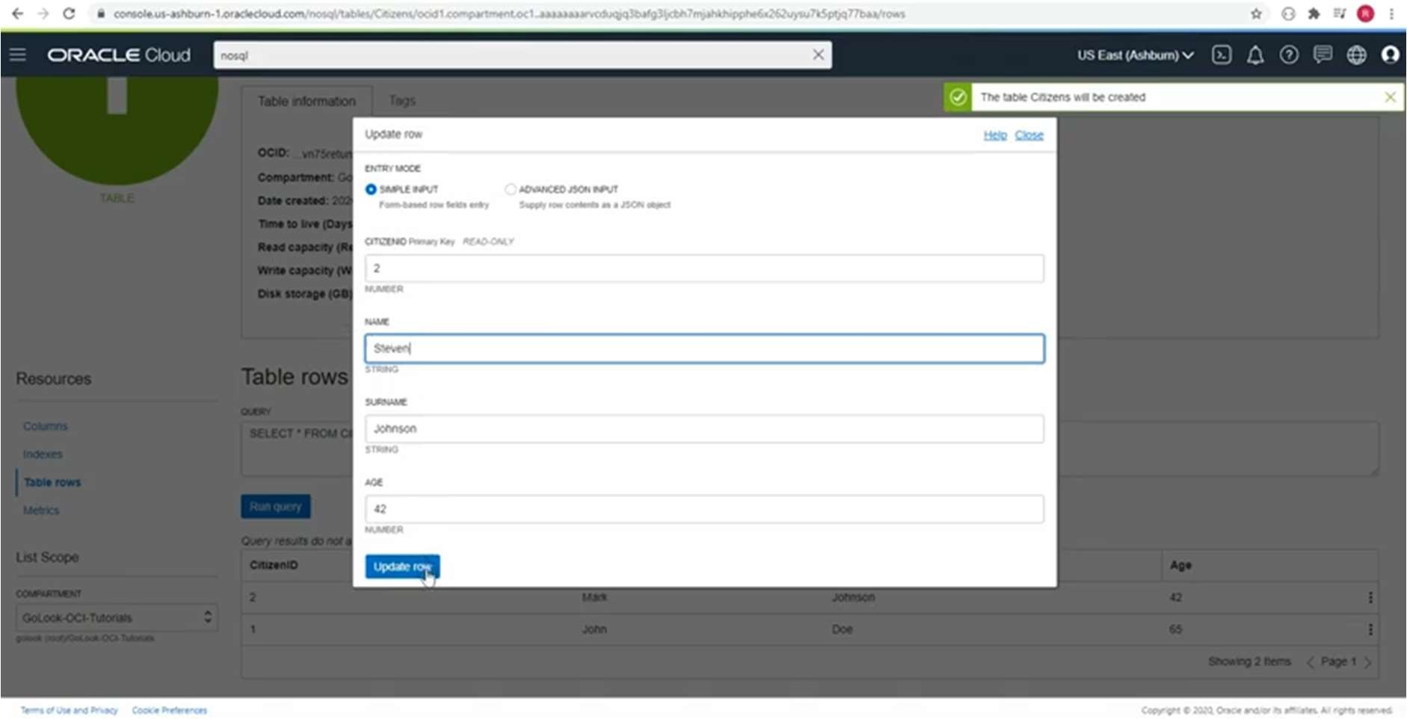

After updating

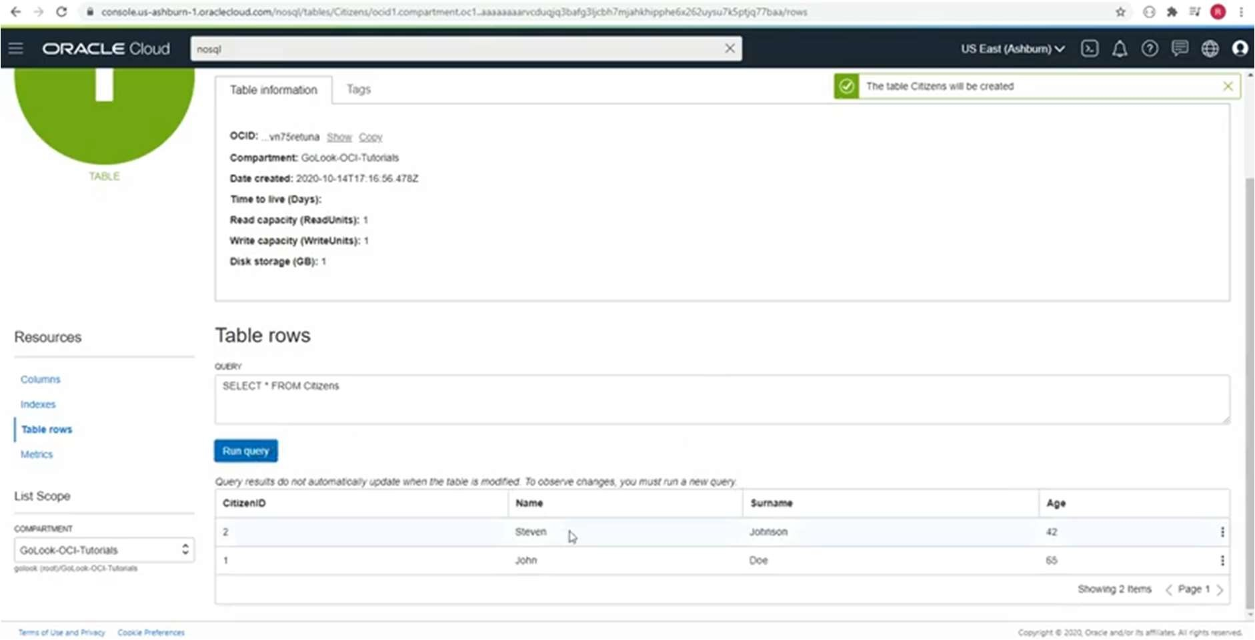

**Step 9** : For deleting row.

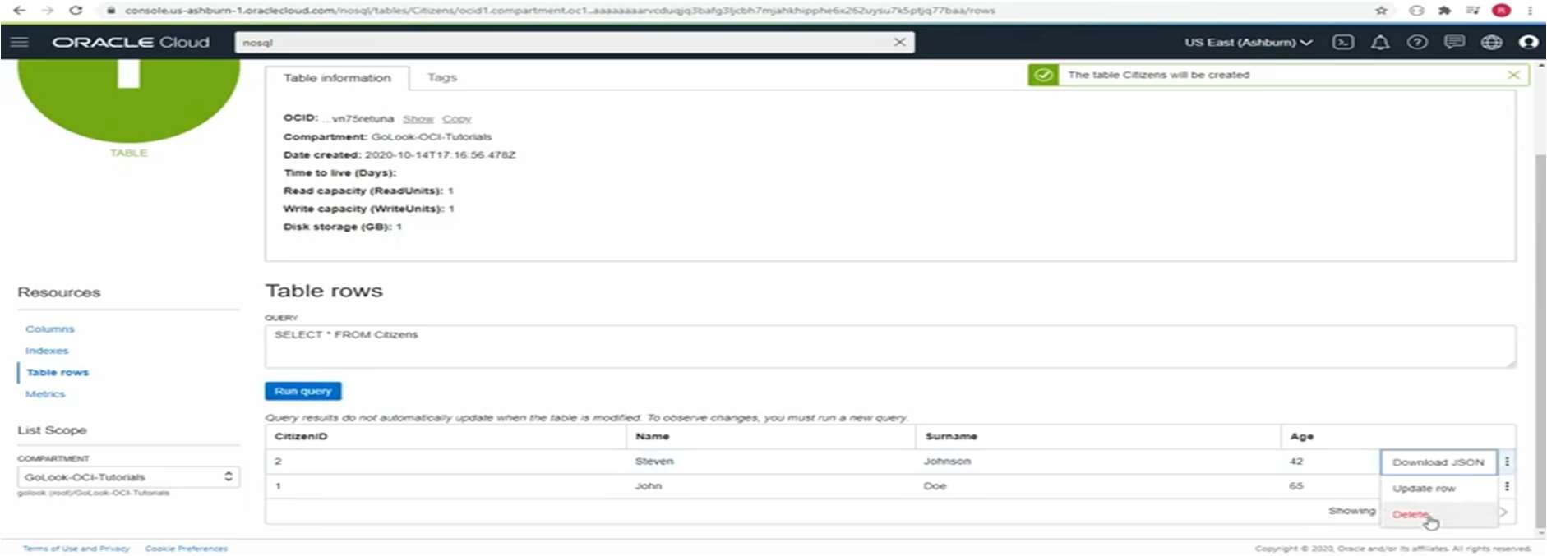

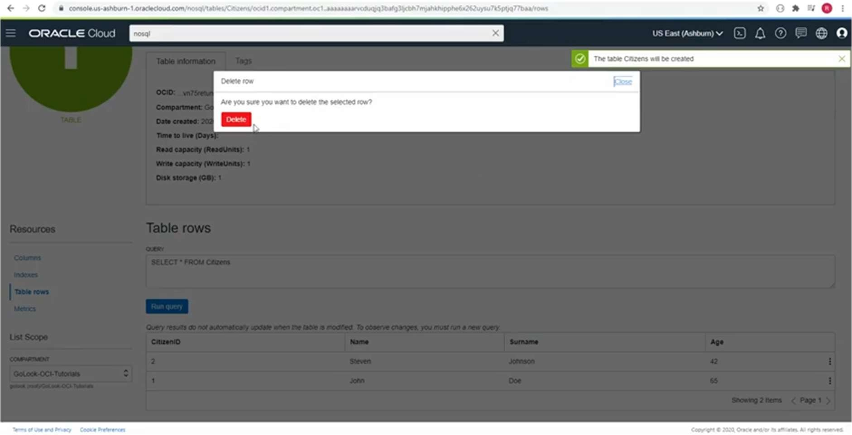

**Step 10** : For deleting Table

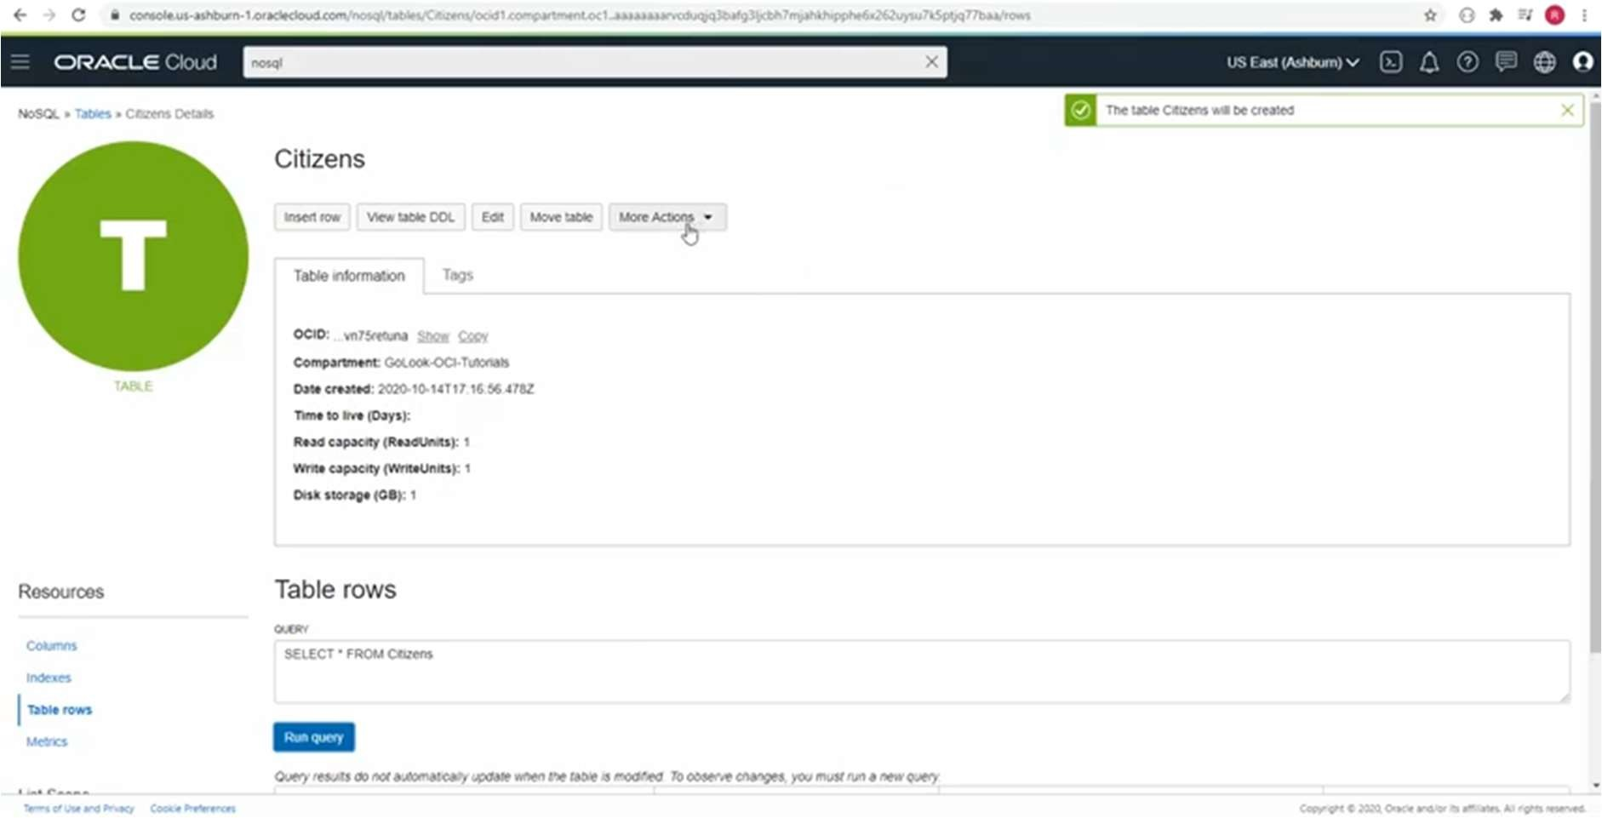

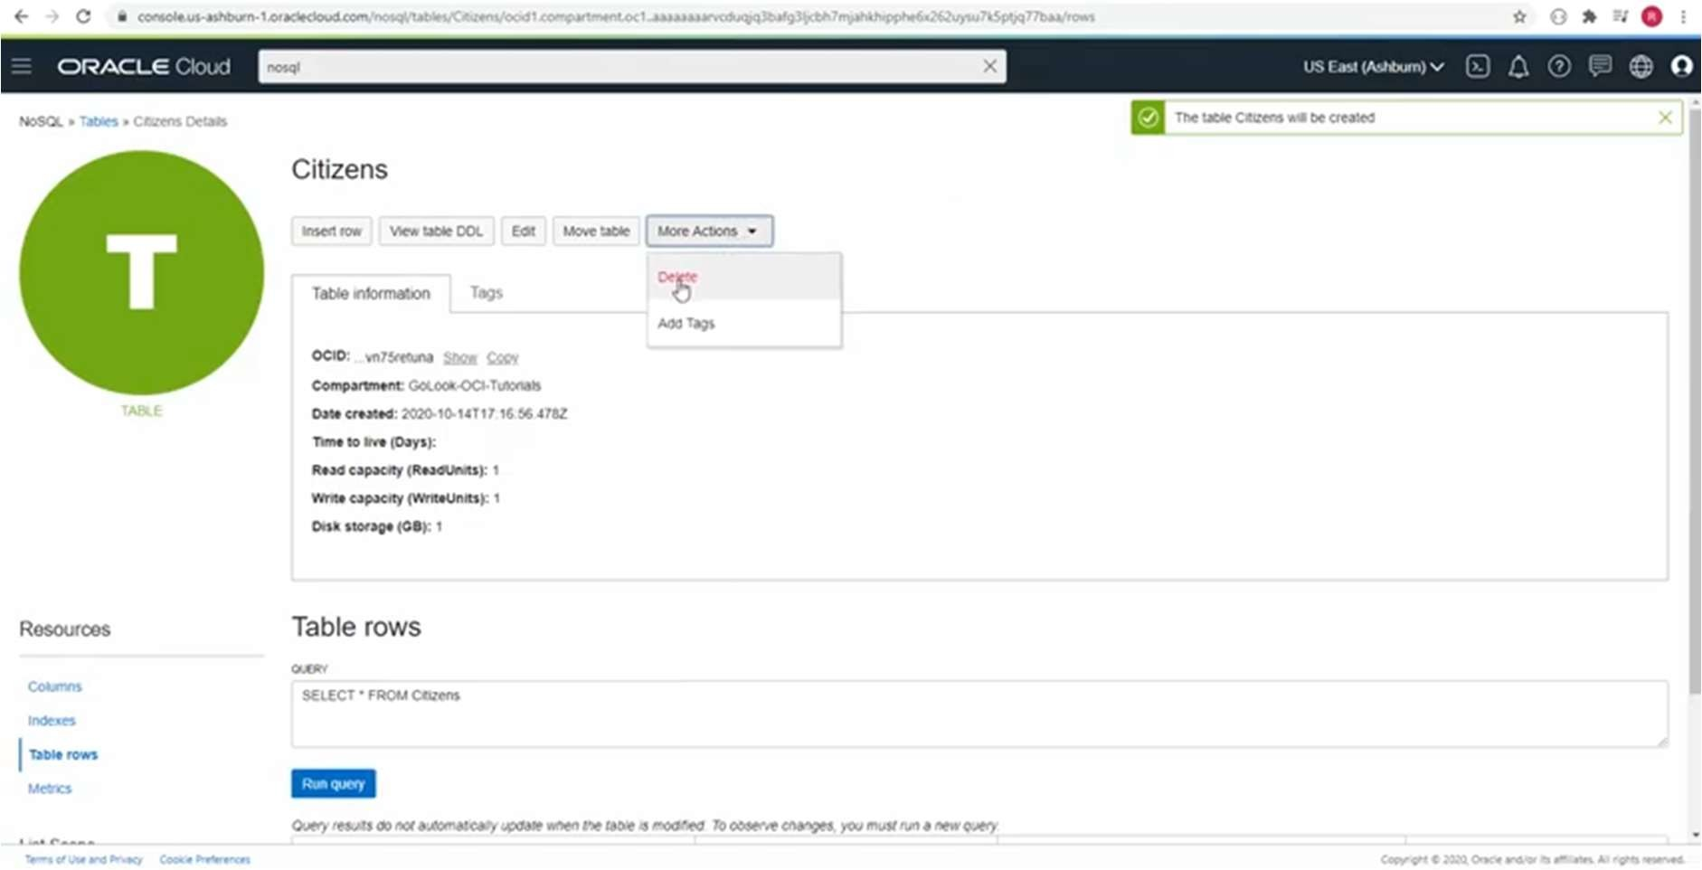

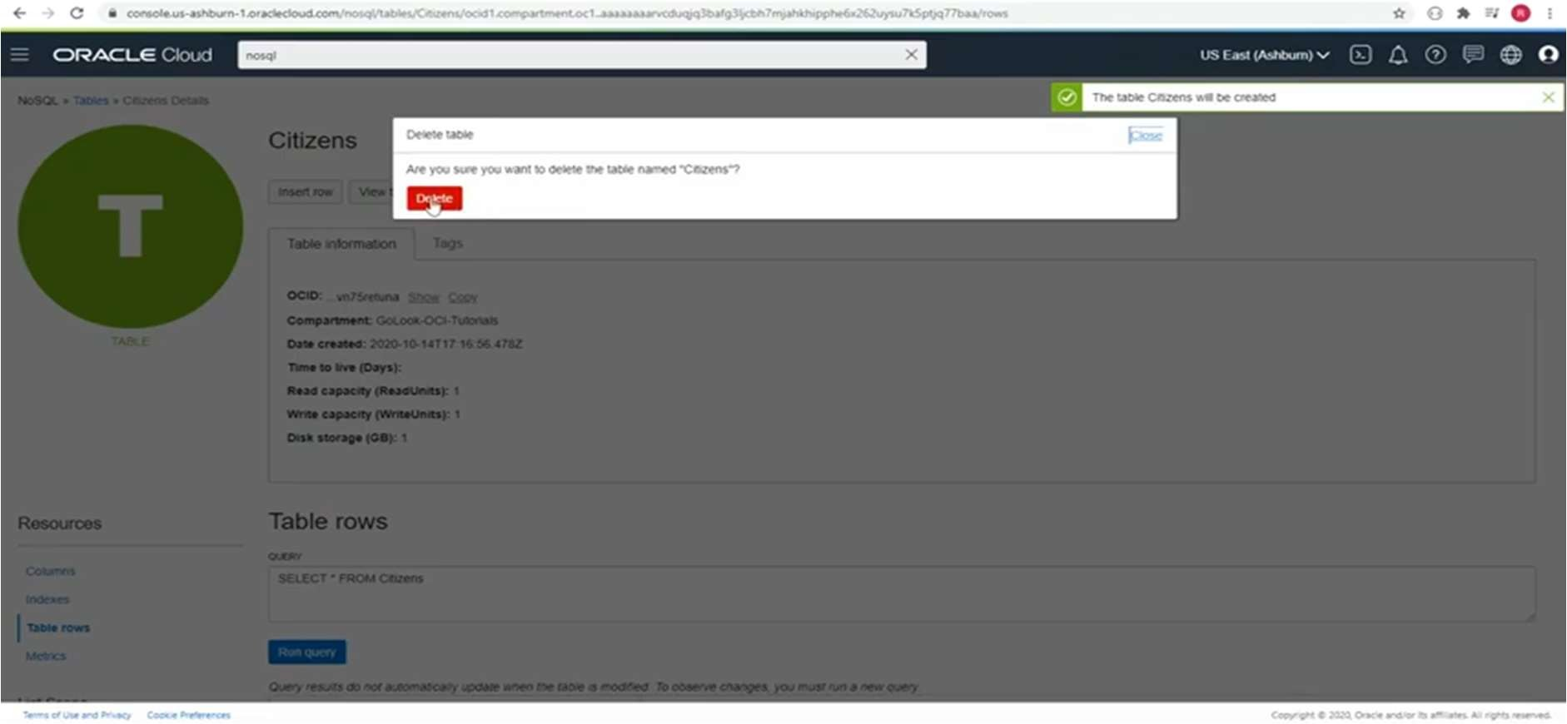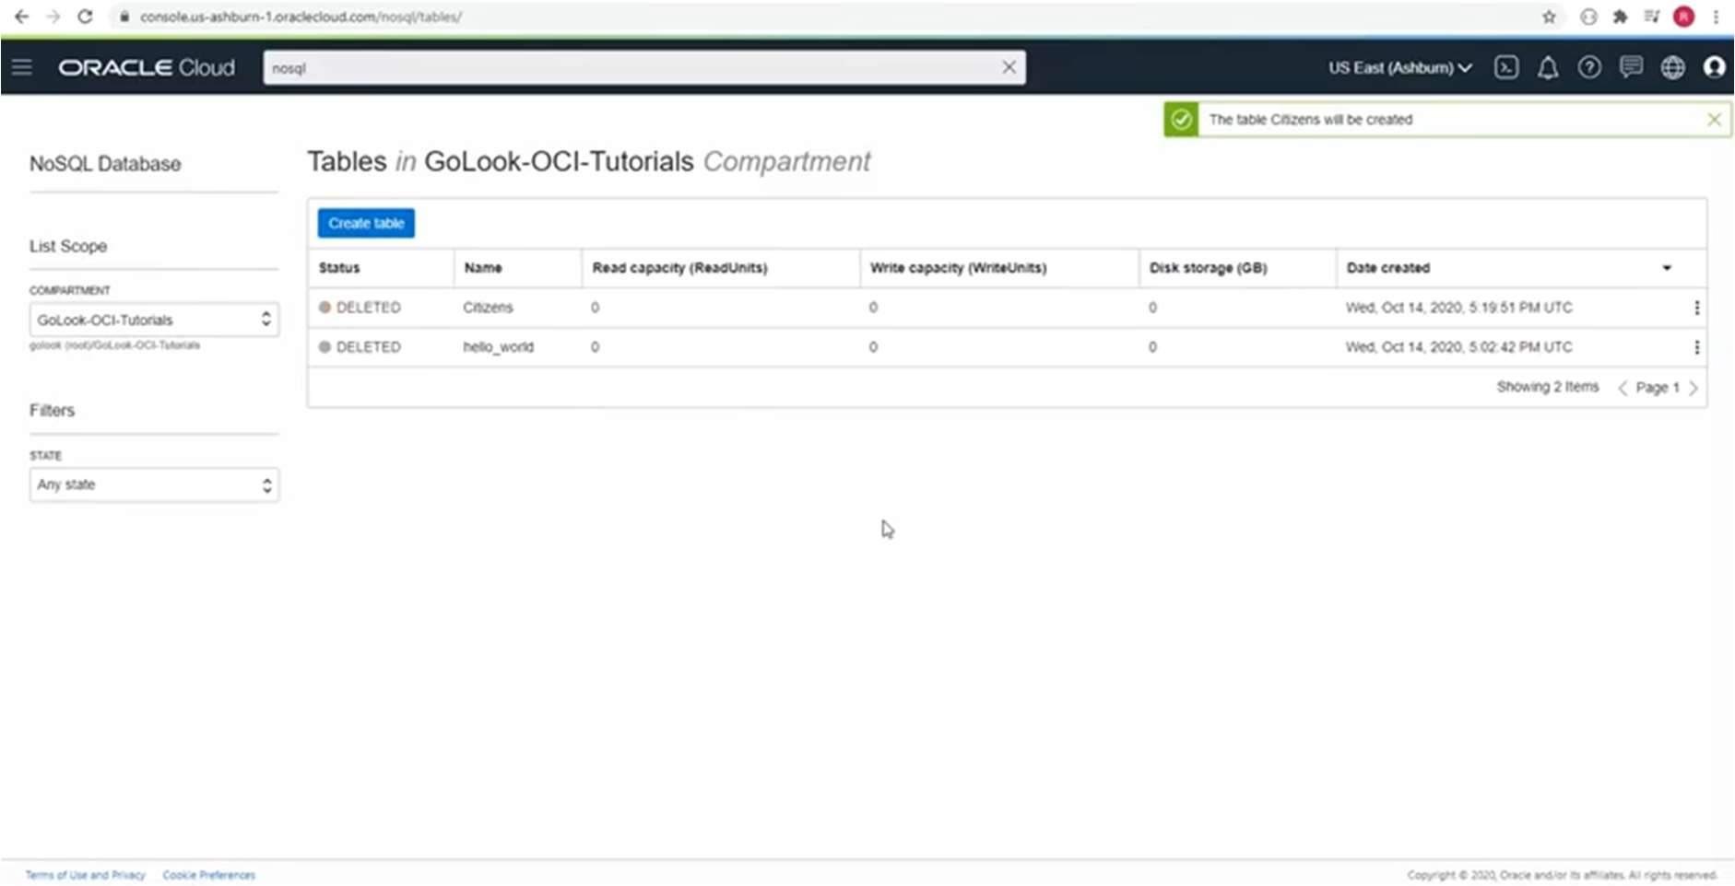

# Practical No 2

Create an XML database and demonstrate insert, update and delete operations on these tables. Issue queries on it.

## Solution :

**Step 1 :** Open Microsoft SQL Server Management Studio.

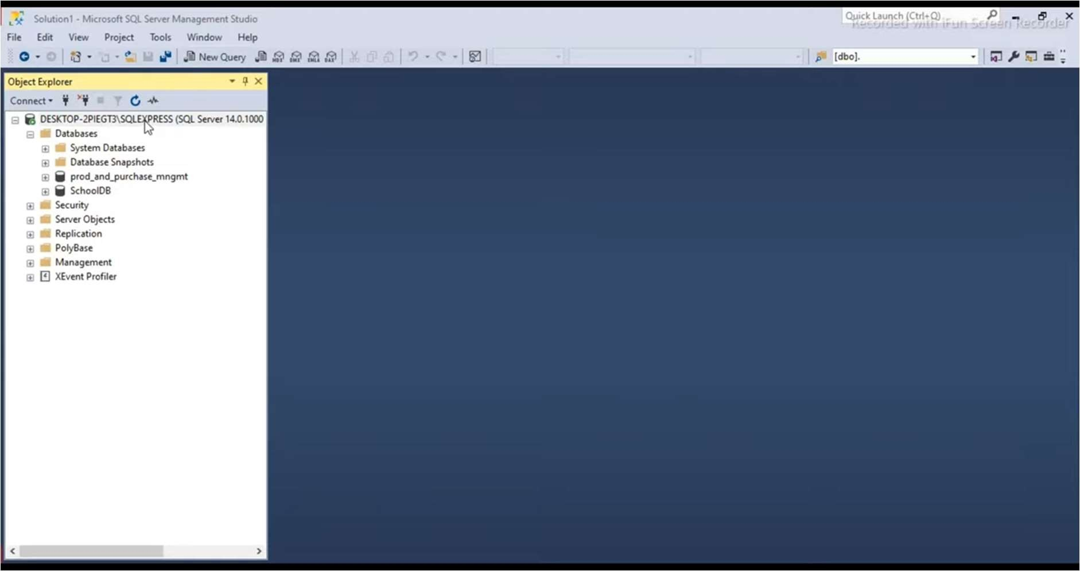

**Step 2 :** Right click on Device name and then select New Query.

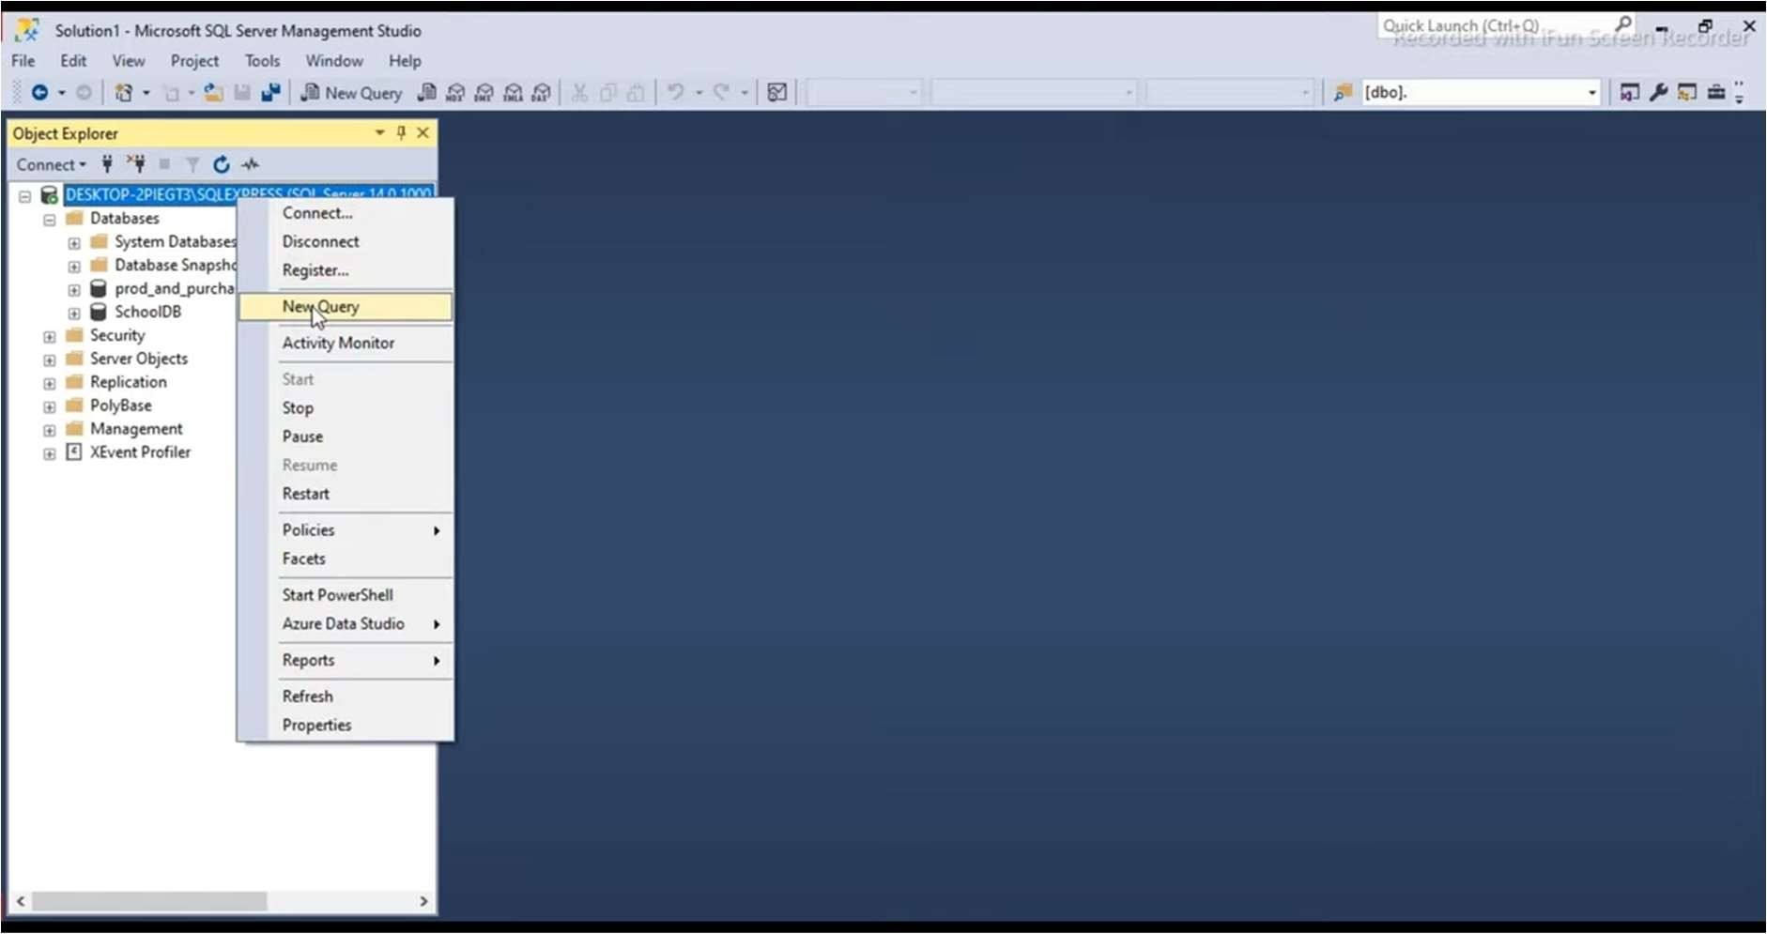

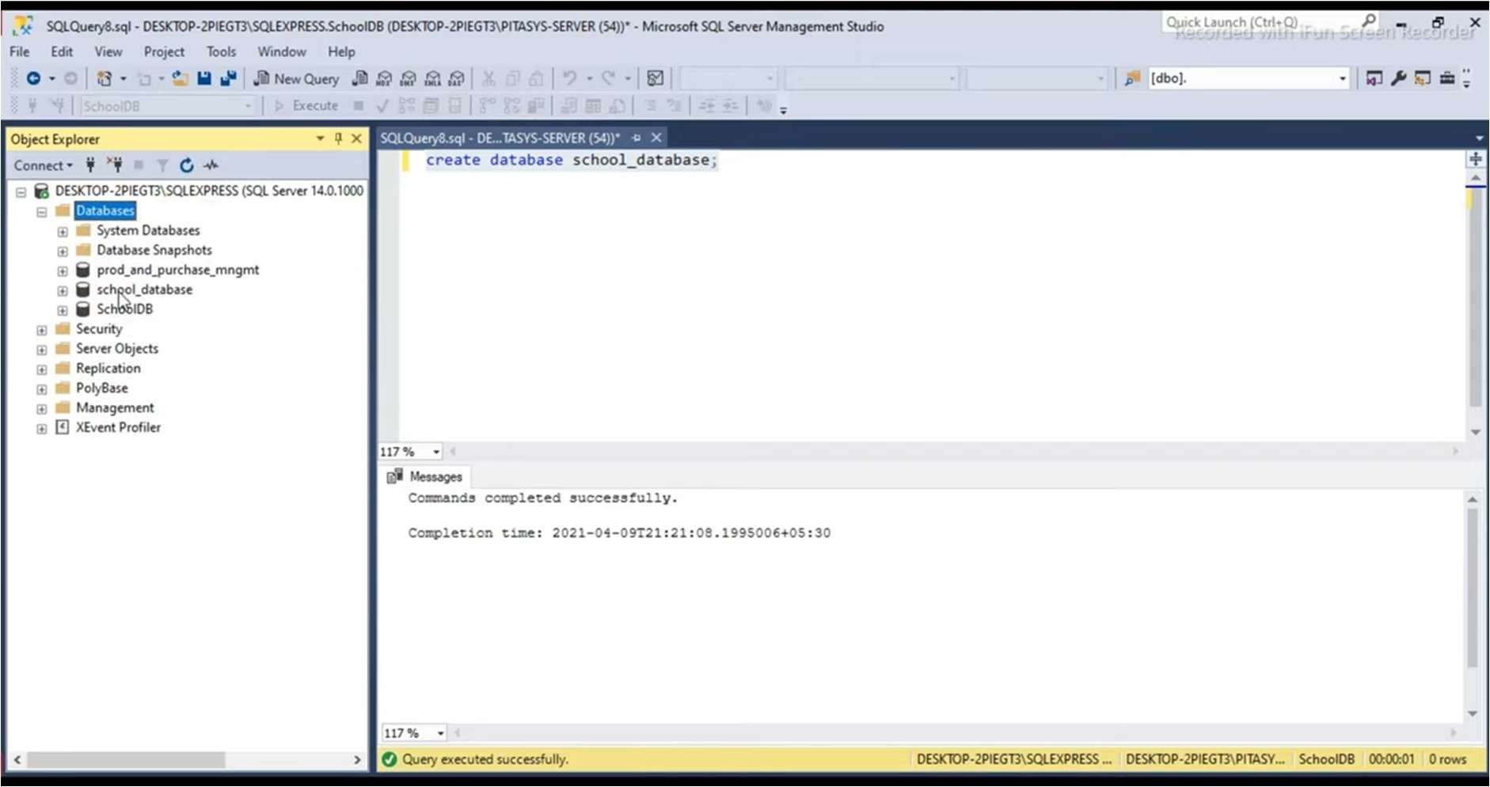**Step 3 :** To create database, pass command **create database** and type name of database which you want to create and then execute the query.

**Step 4 :** To create table , first set the database which you want by using **use** command.

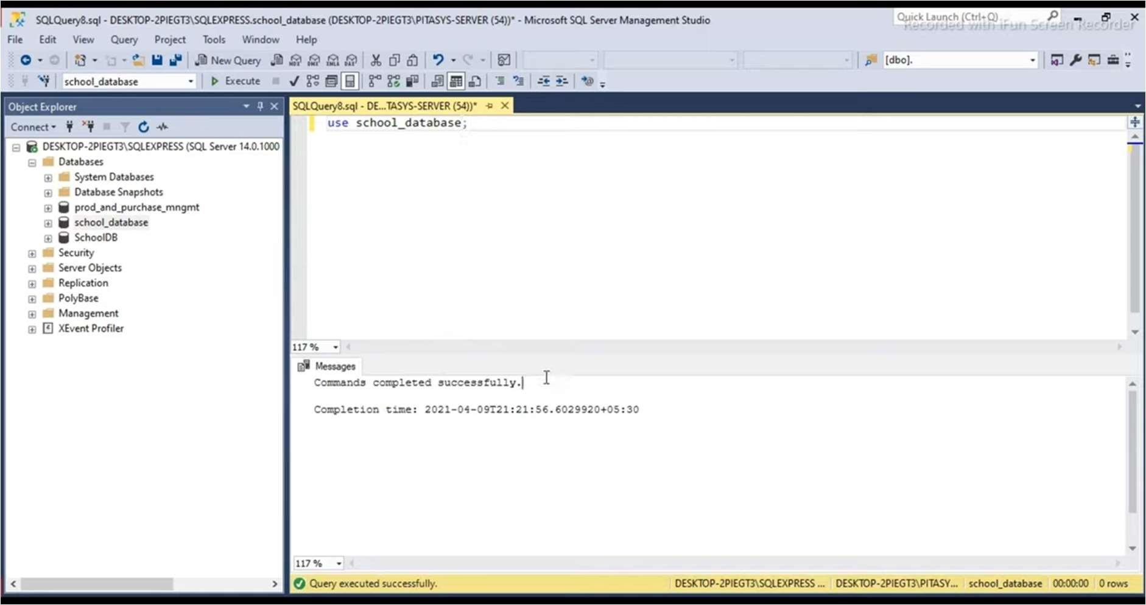

**Step 5 :** For creating table , pass command **create table** and name of table.

Create columns as per requirement as shown below .

To insert columns write query in round brackets() and execute it.

Eg : ***insert into students*** (column_names)

***values***(‘Lalit’);

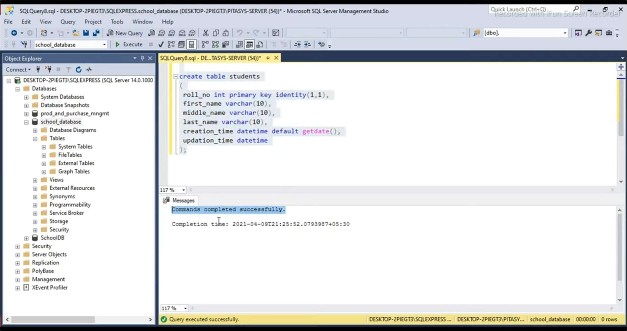

Once you inserted all columns then execute the query , a table is created.

**Step 6** : To view the table , execute command **select * from students**

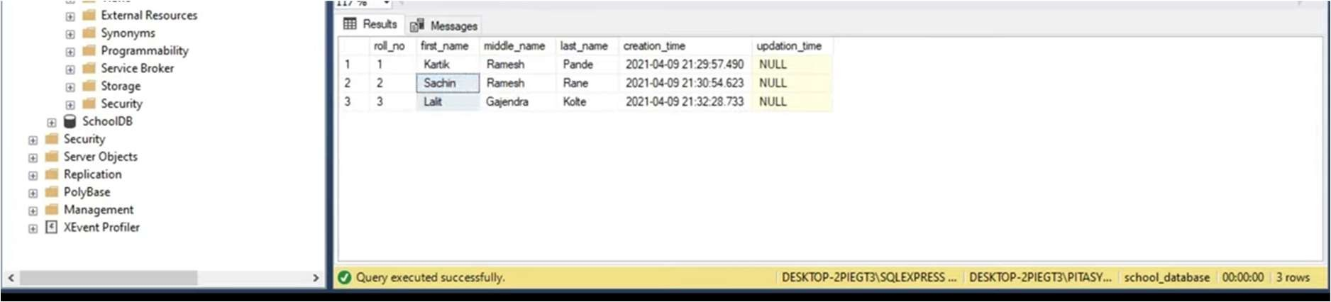

**Step 7 :** To Update table use **update command.**

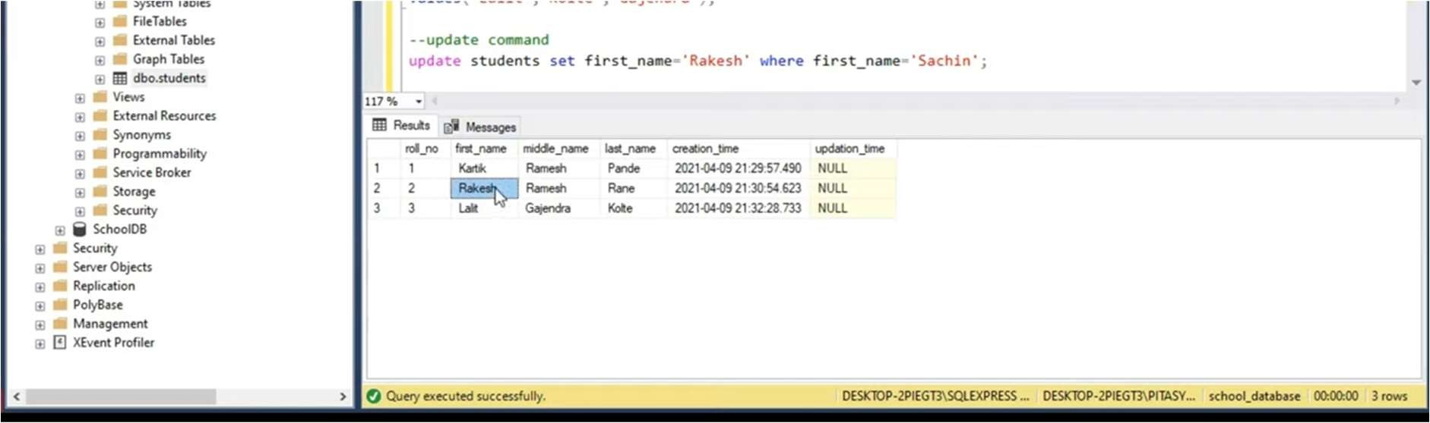

**Step 8 :** To delete column use delete command.

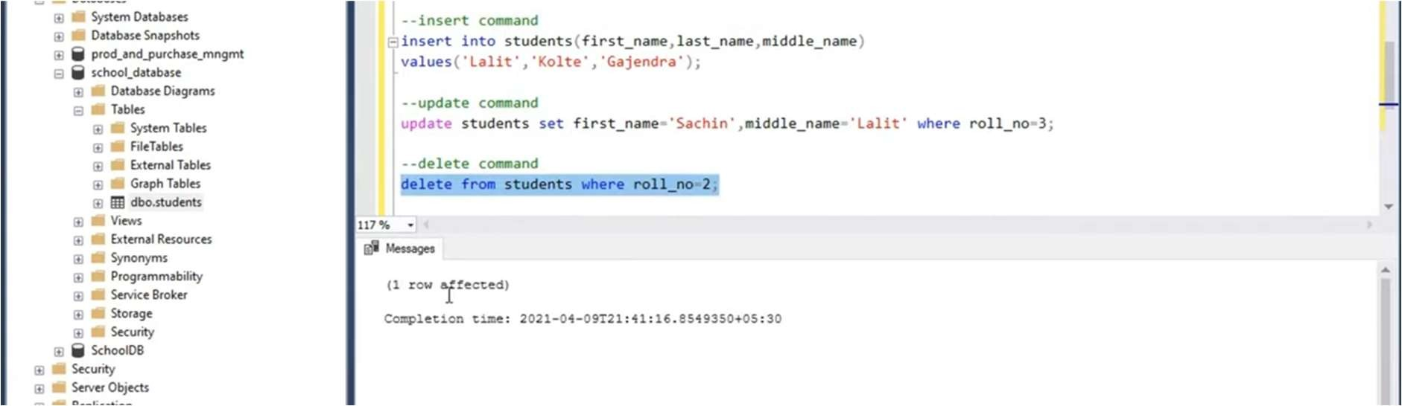

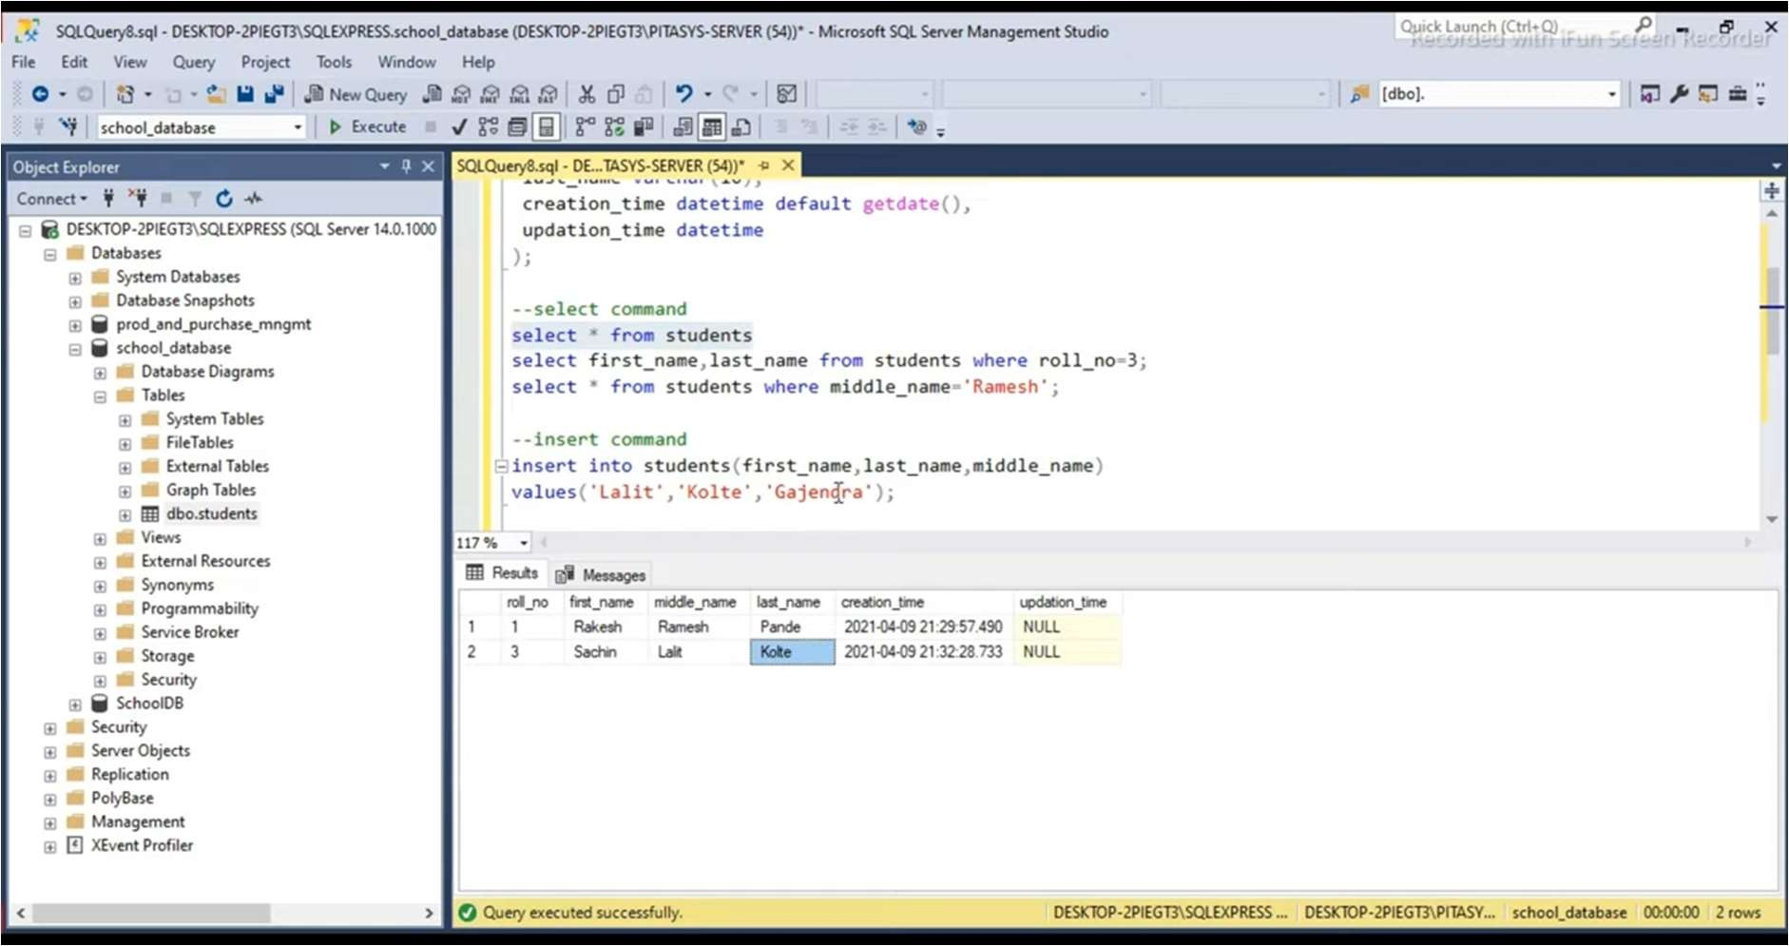

**Step 9 :** For executing queries For eg :

1. ***Select from*** student ***where*** middle_name= ’Ramesh’;

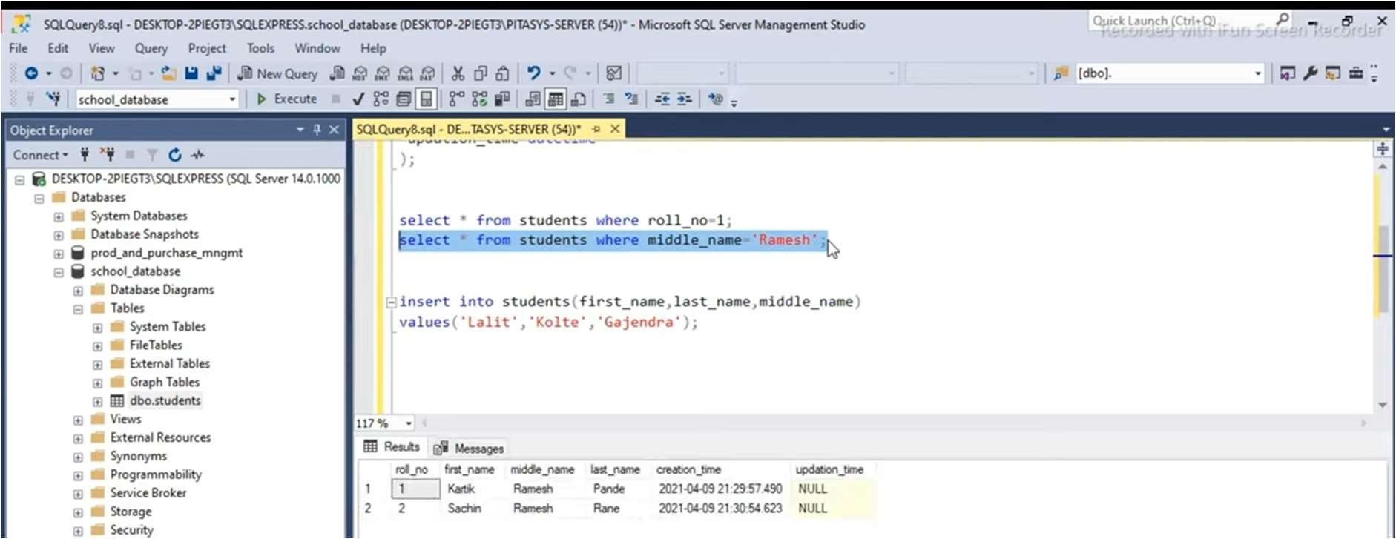

1. ***Select from*** student ***where*** roll no=3;

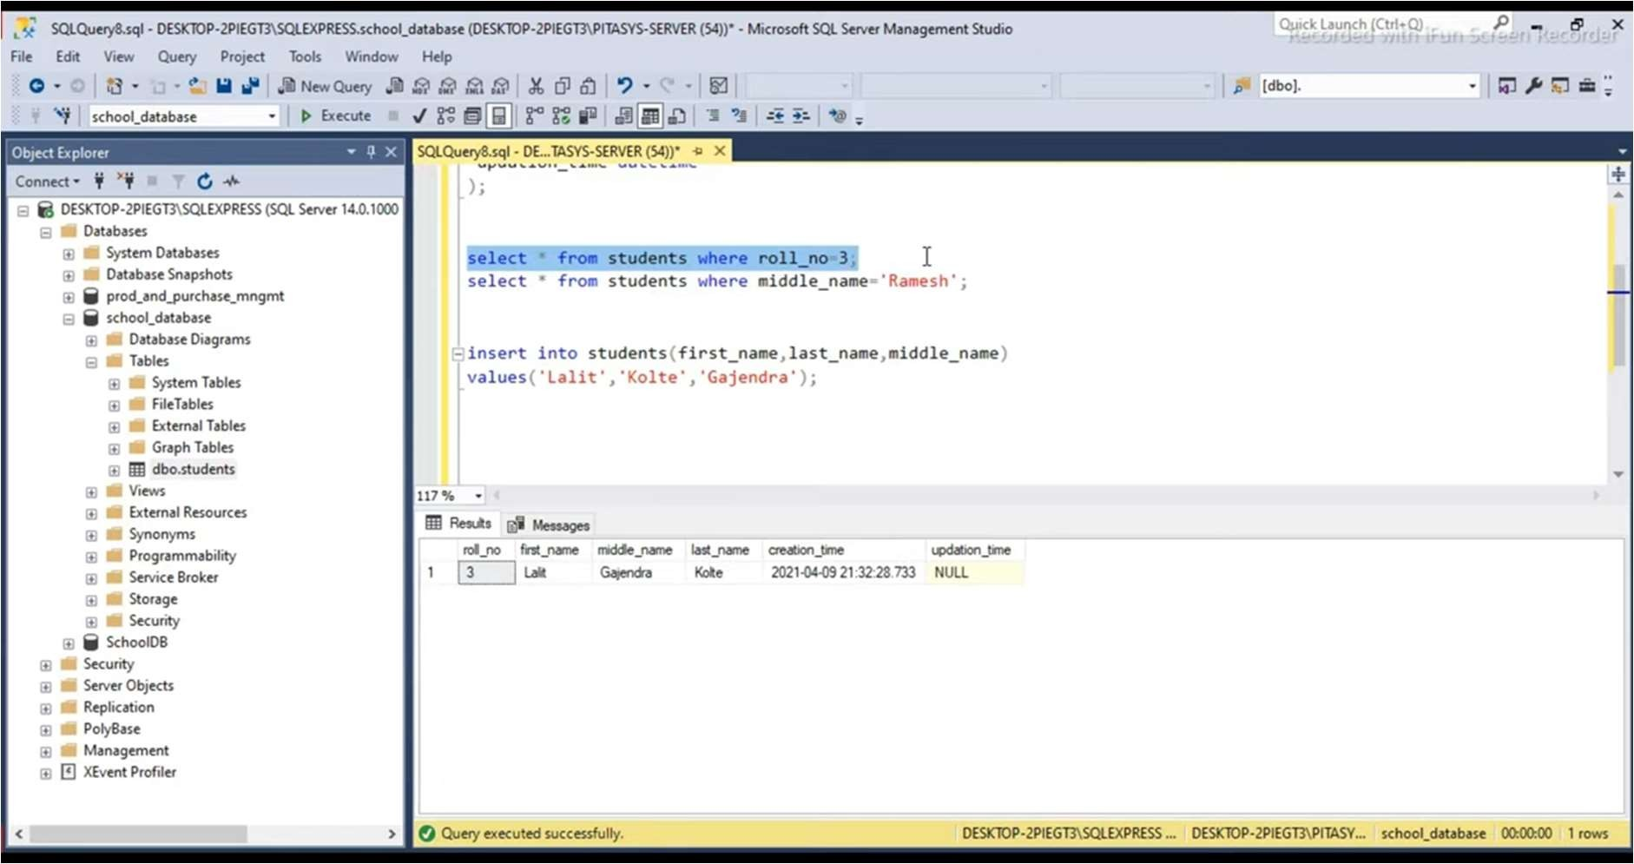

## Practical No 5

Create a temporal database and issue queries on it.

## Solution :

**Step 1 :** Start Open Microsoft SQL Server Management Studio.

**Step 2 :** Create Temporal table.

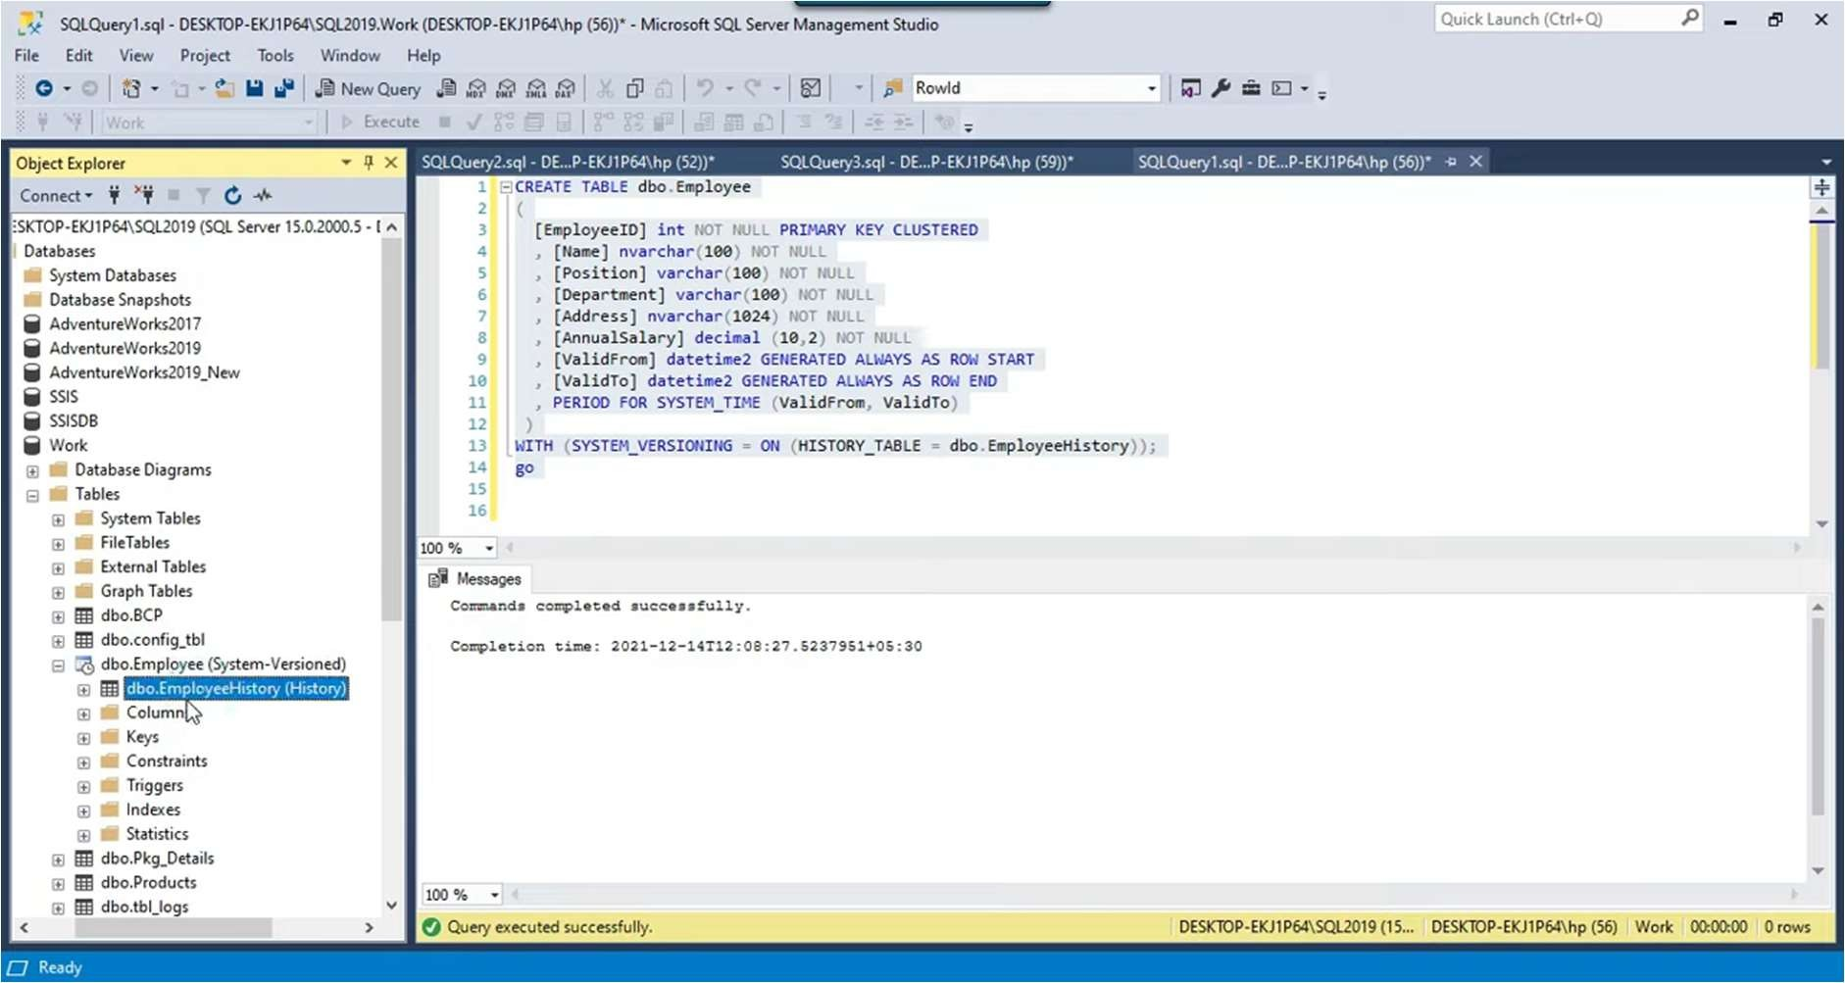

System versioned temporal table is created and Employee history table is created as well.

**Step 3 :** Using **insert** command , insert records in table.

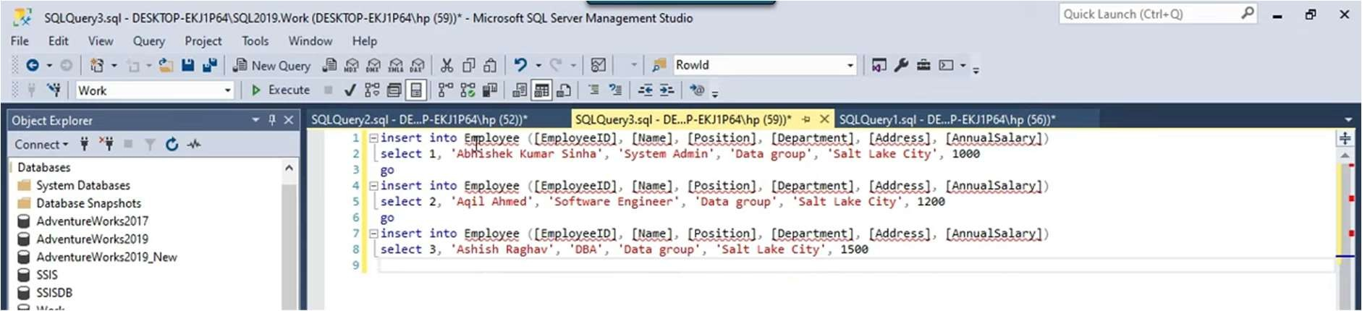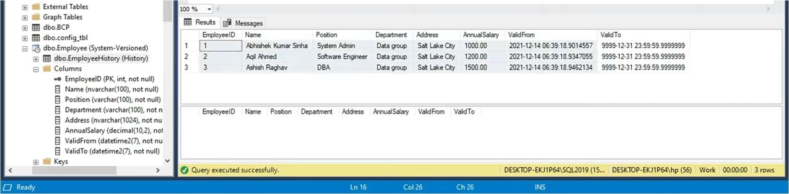

**Step 4 :** To Update temporal table.

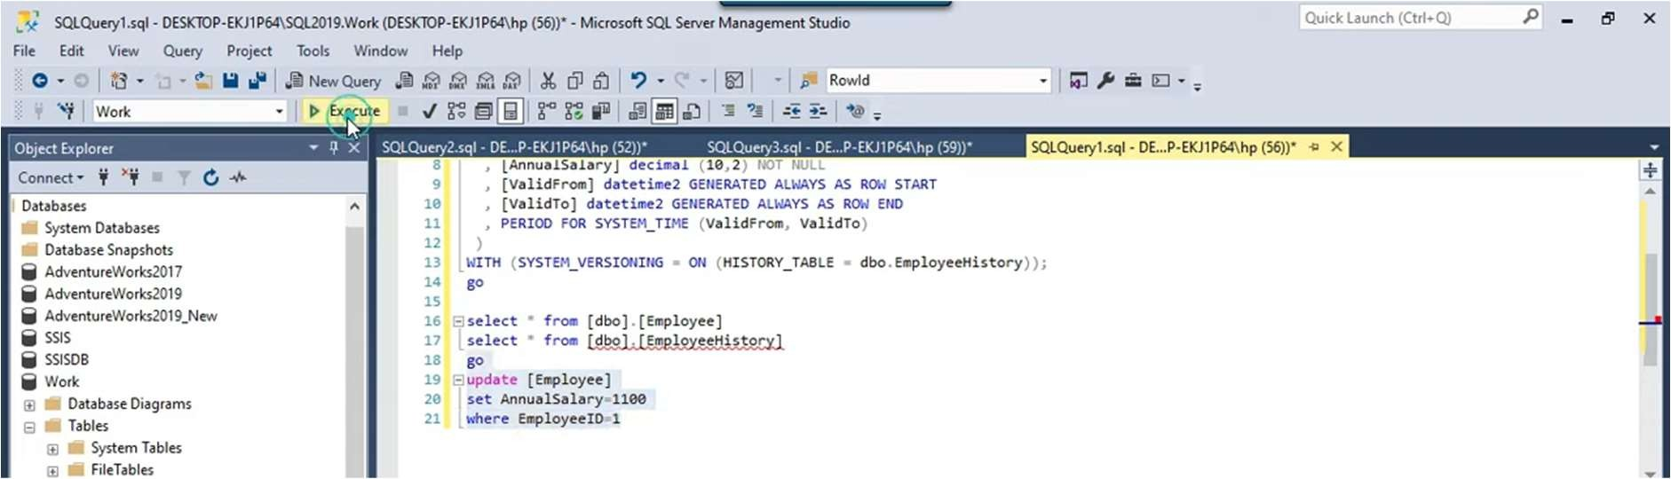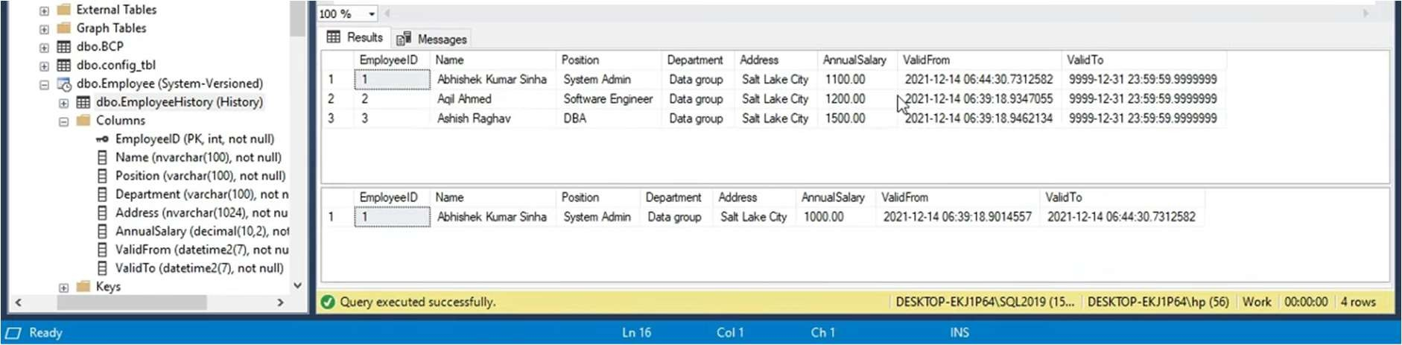

Record is updated.

**Step 5 :** To delete record from temporal table.

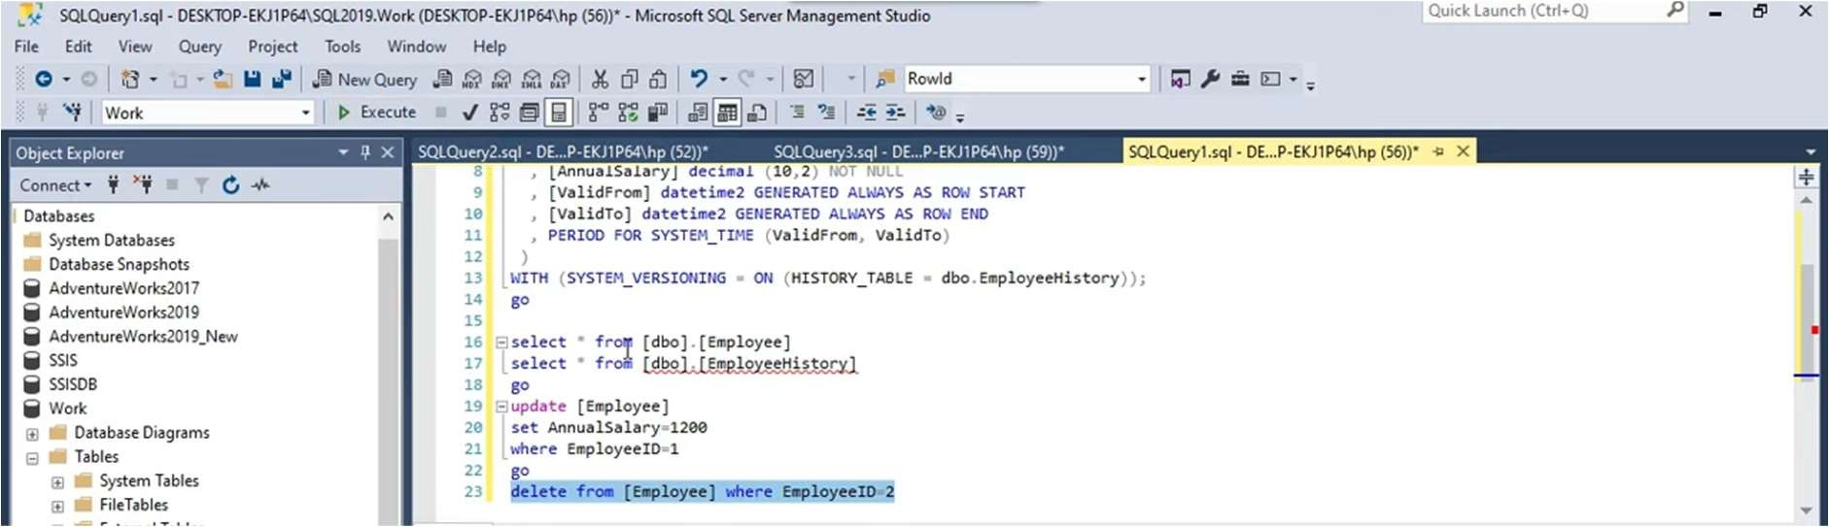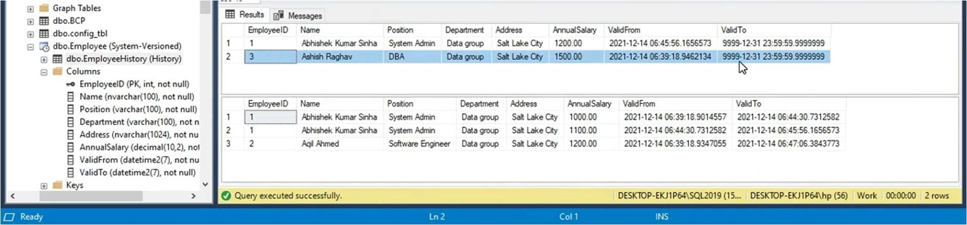

## Practical No 10

Demonstrate the use of data management and operations using NoSQL in the Cloud.

## Solution :

**Step 1 : :** Start [www.oracle.com](http://www.oracle.com/) Sign in 0R Sign up

**Step 2 :** Open database management console.

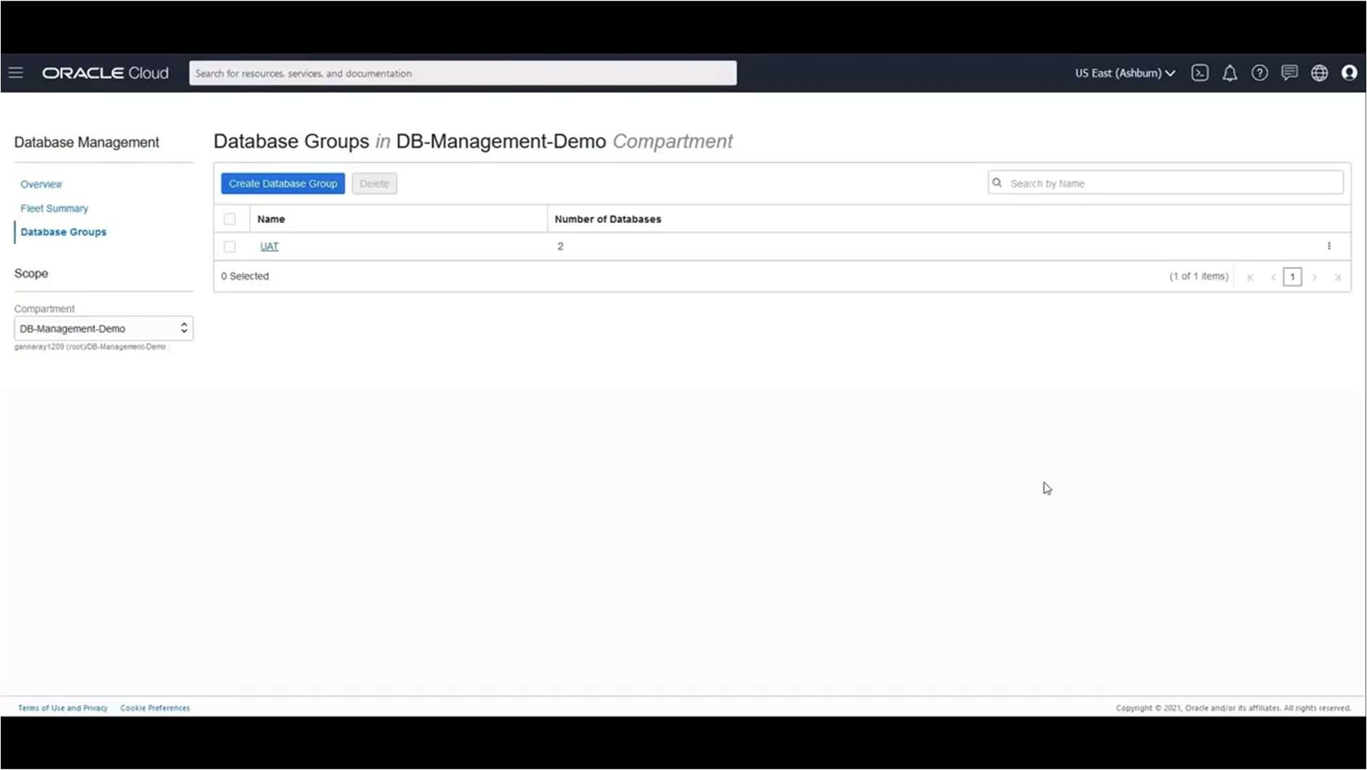

**Step 3 :** Click on UAT database Group.

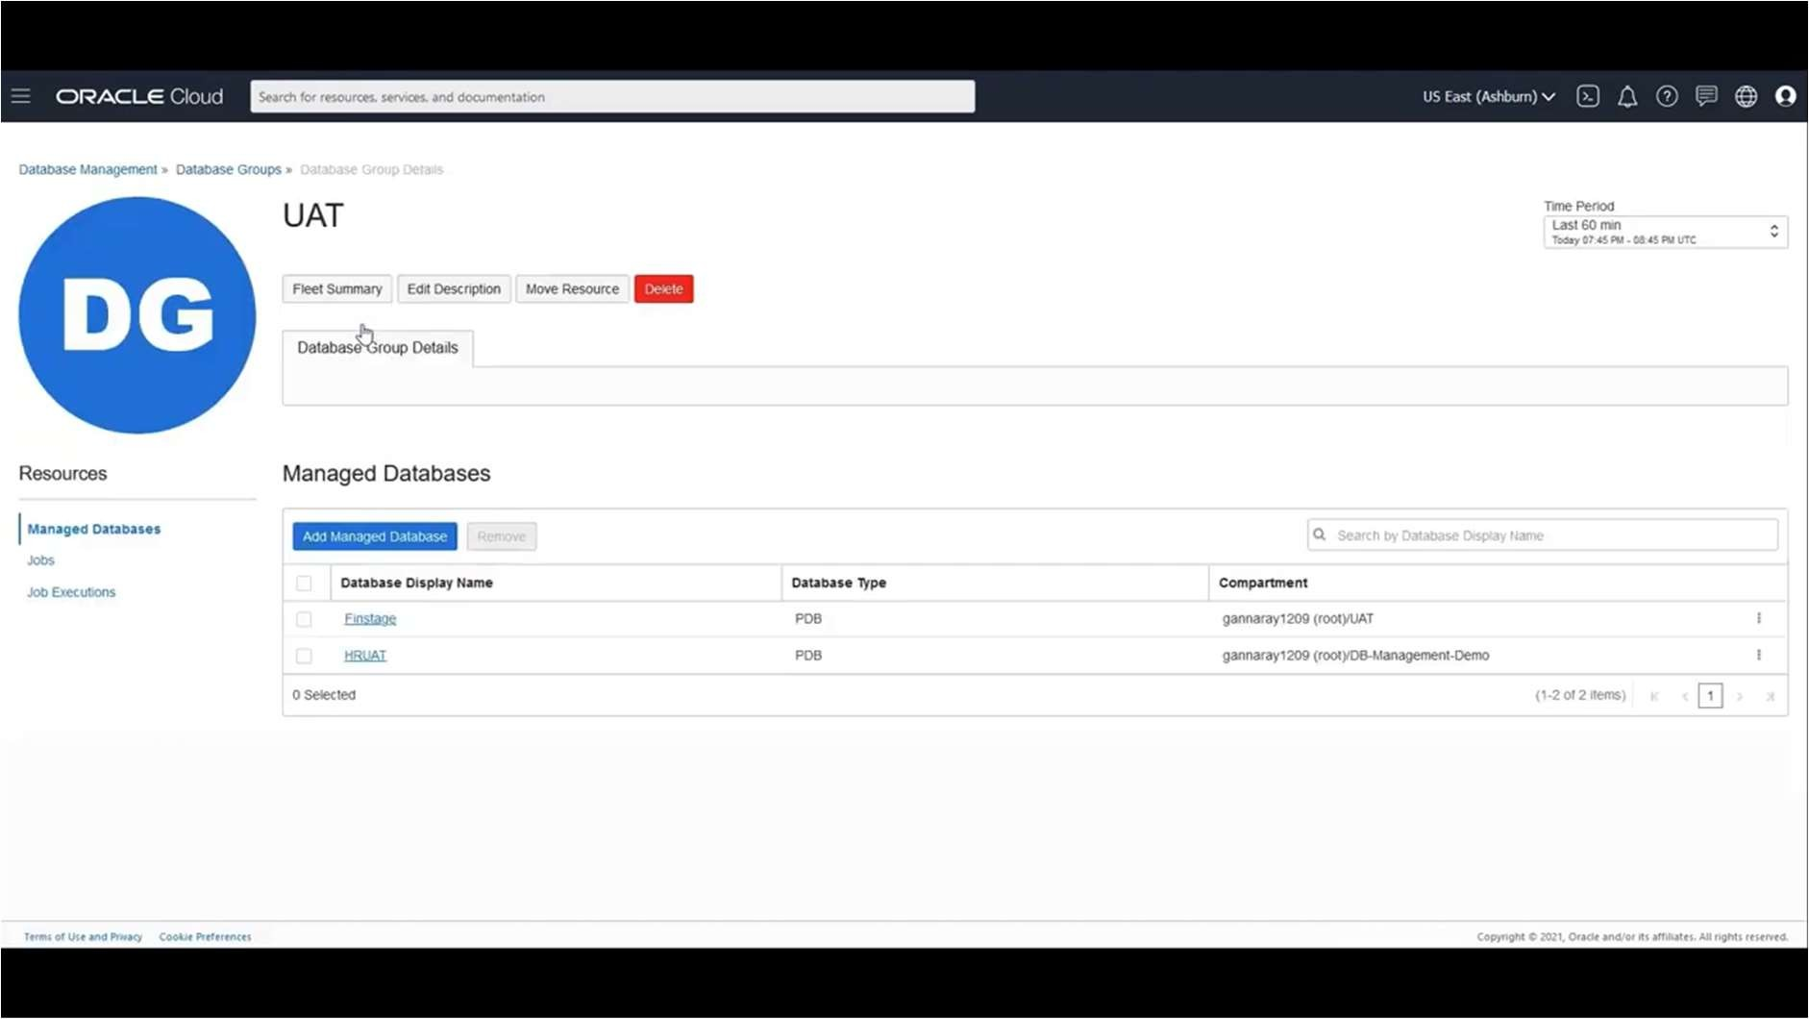

**Step 4 :** To create Job.

Click on create Job.

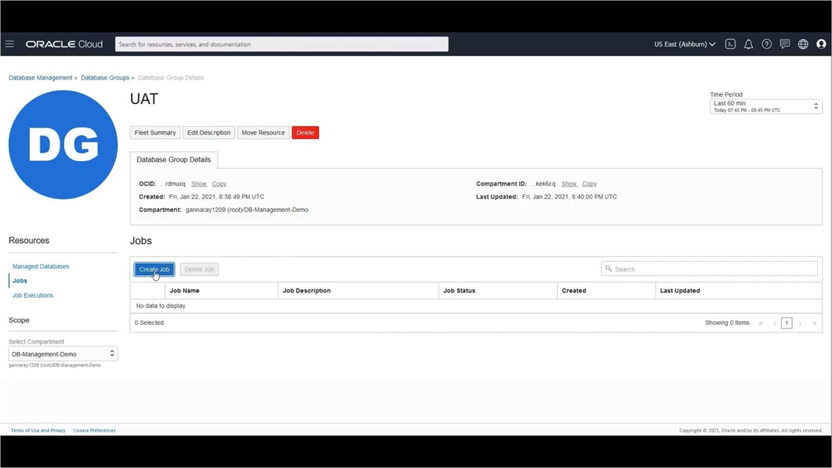

**Step 5 :** Fill the basic information in the box like Job name , description , SQL type etc.

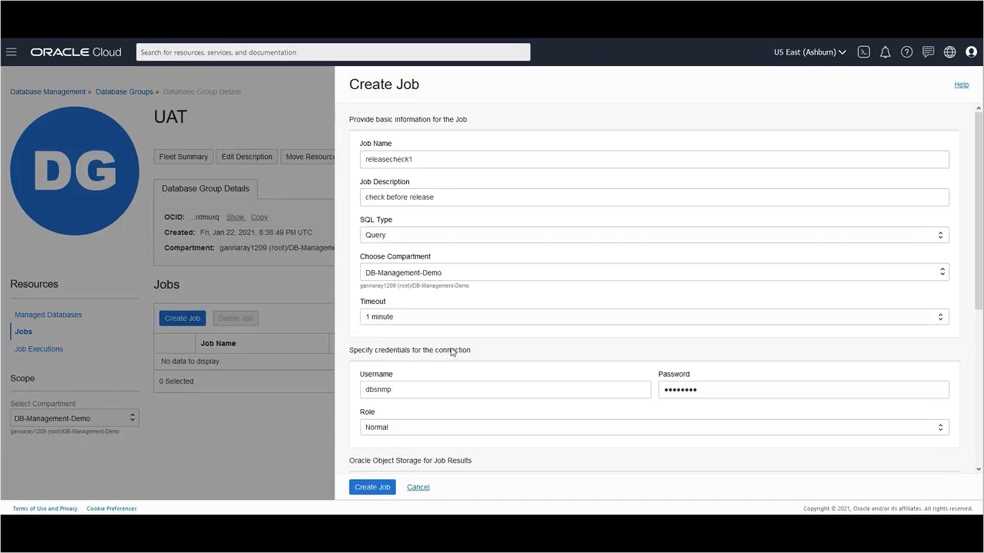

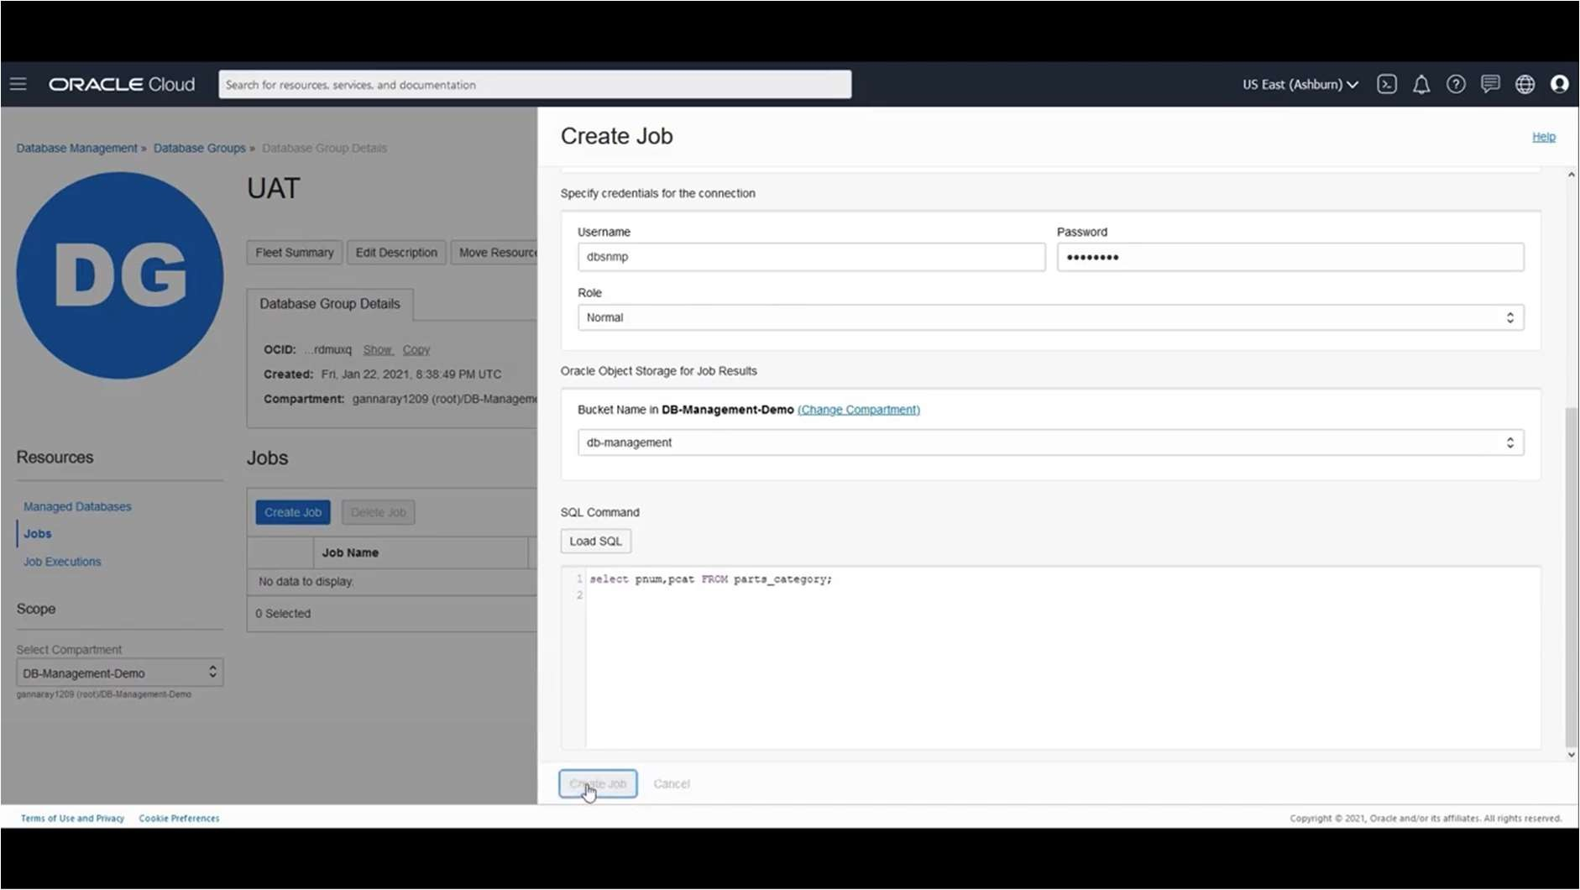

Job release check has created.

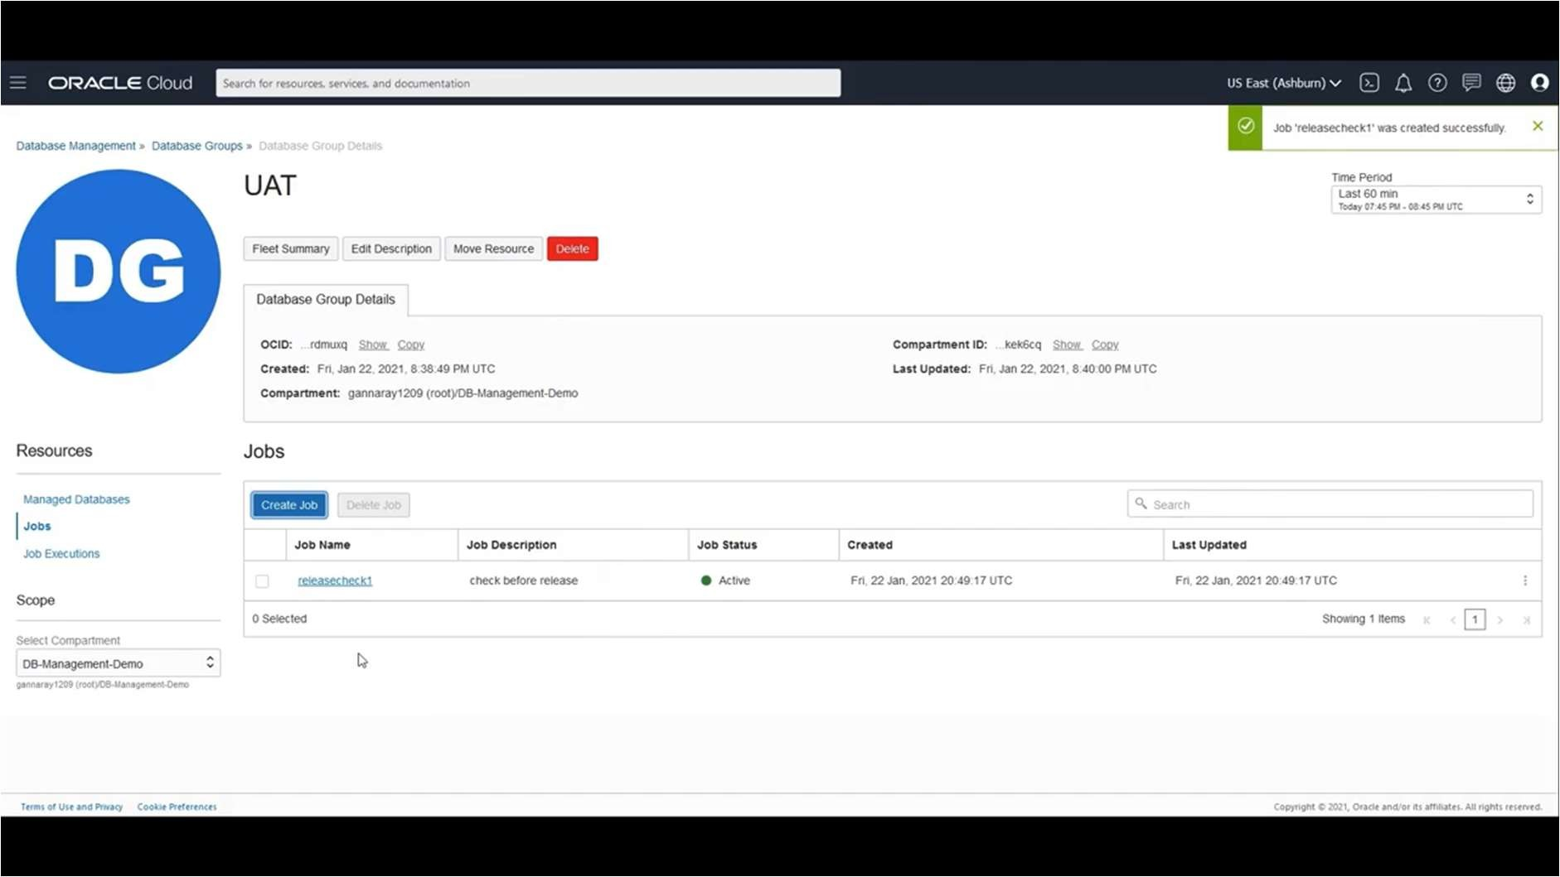

**Step 6 :** To check job execution , click on job name.

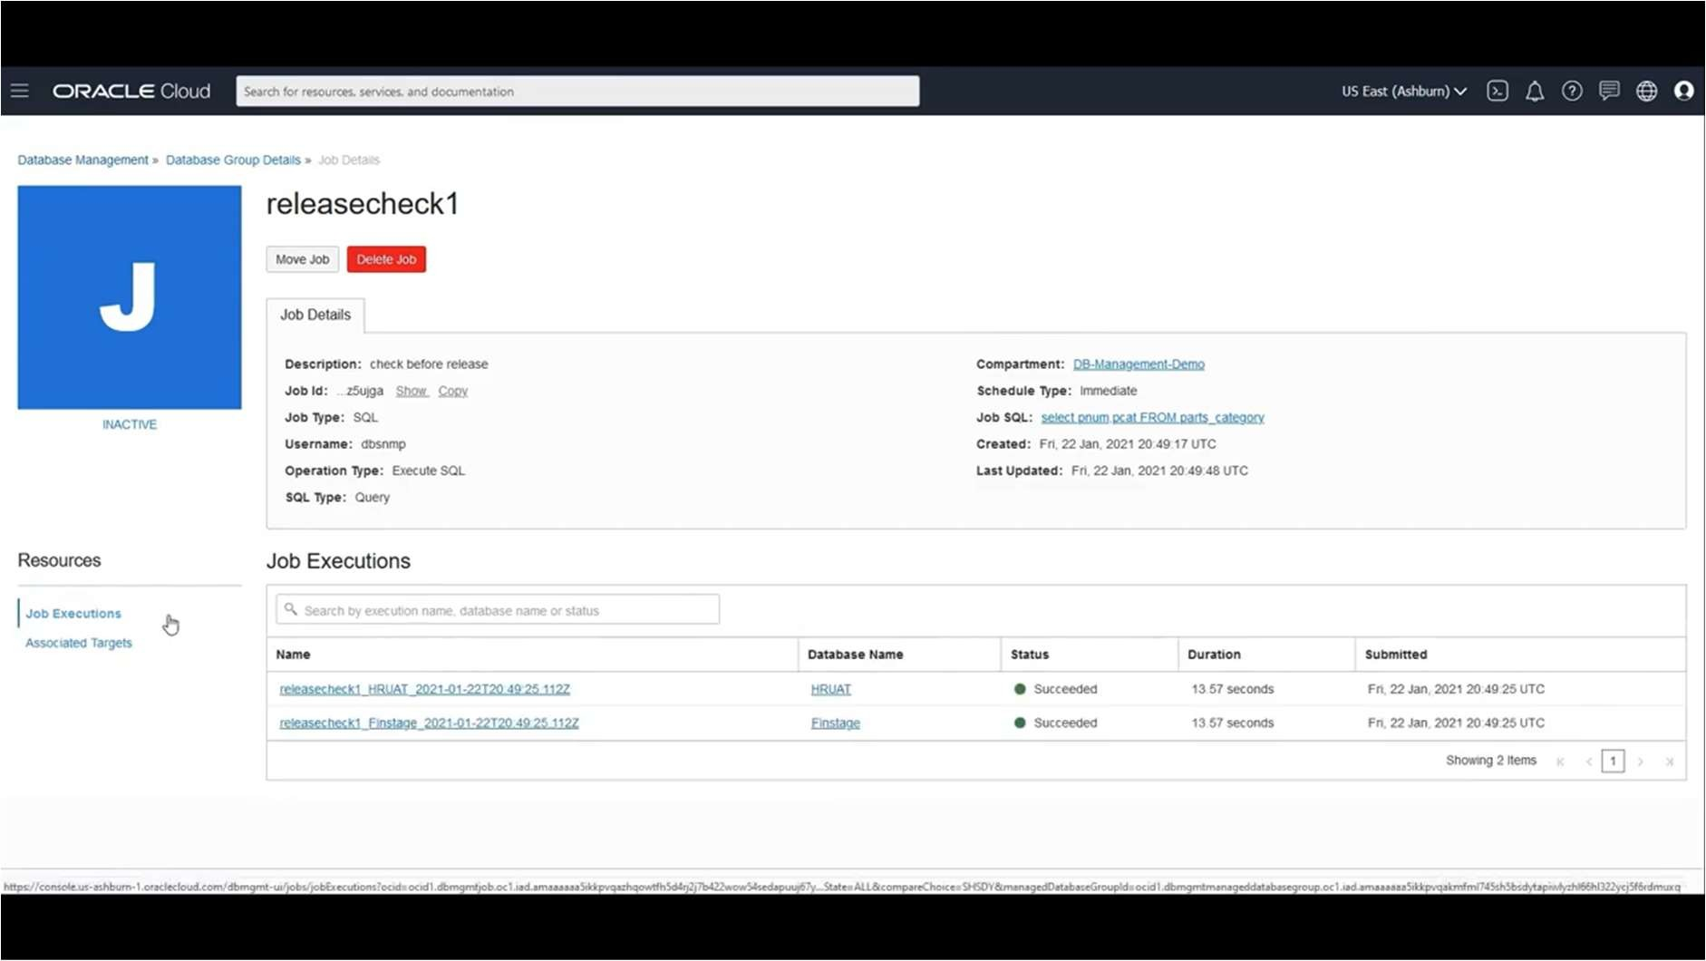

**Step 7 :** To check job execution output , click on one of the executions.

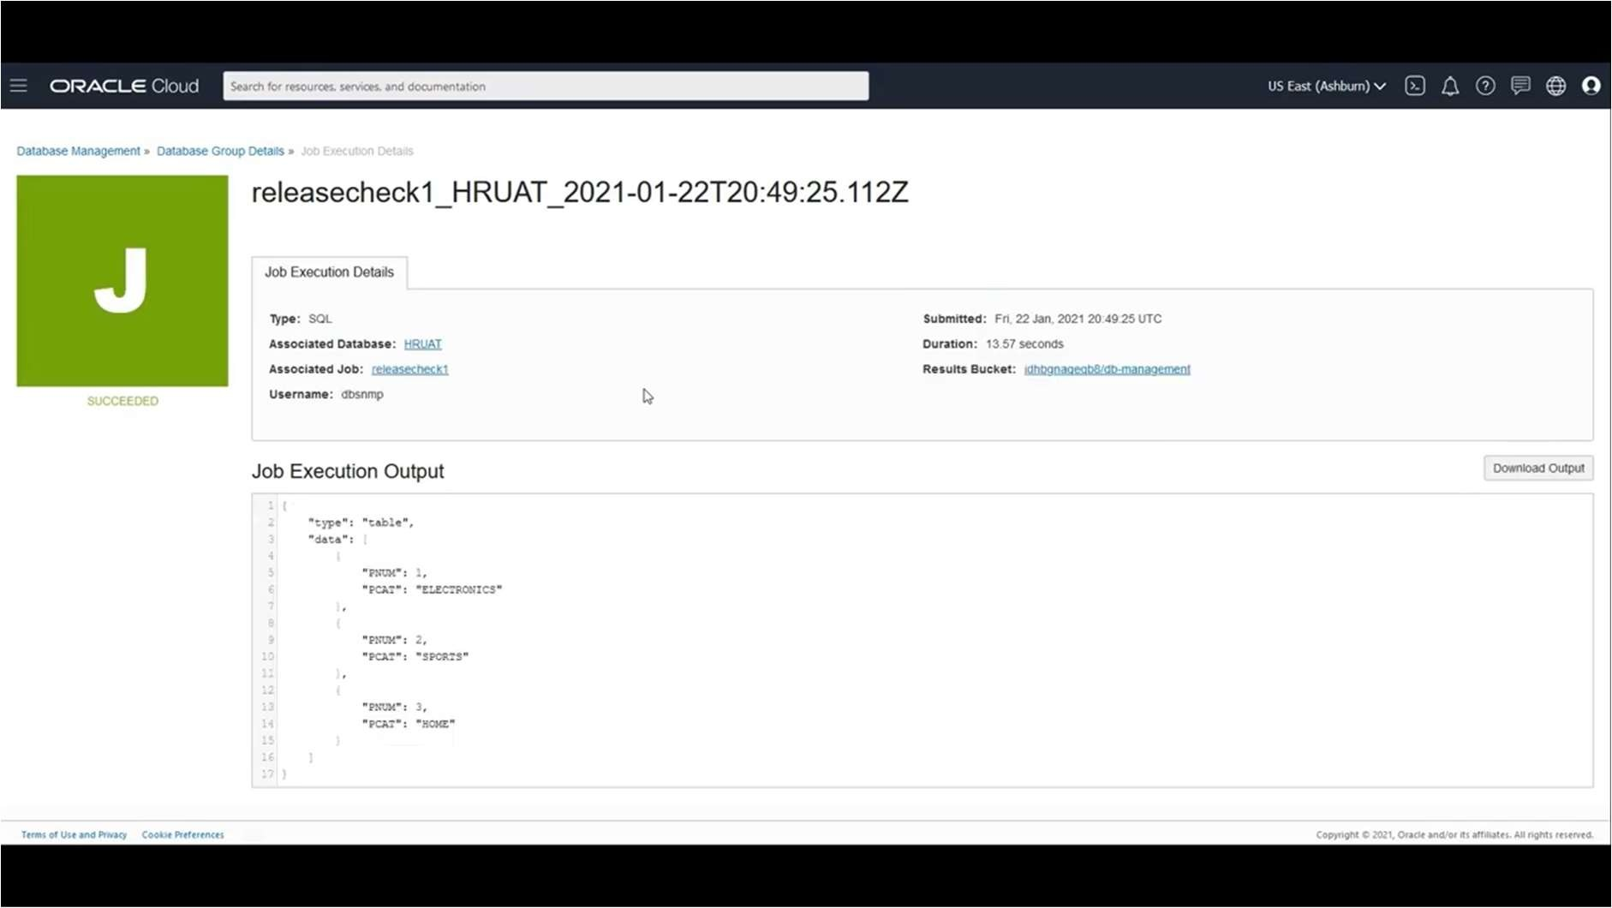

**Step 8 :** To delete Job , click on above option **Delete Job.**

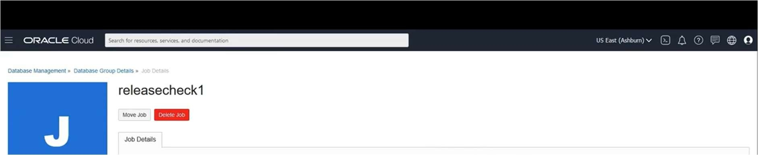

# Practical No 6

Demonstrate the Accessing and Storing and performing CRUD operations in

1. MongoDB
2. Redis

## Solution :

**Step 1 :** Start Open MongoDB.

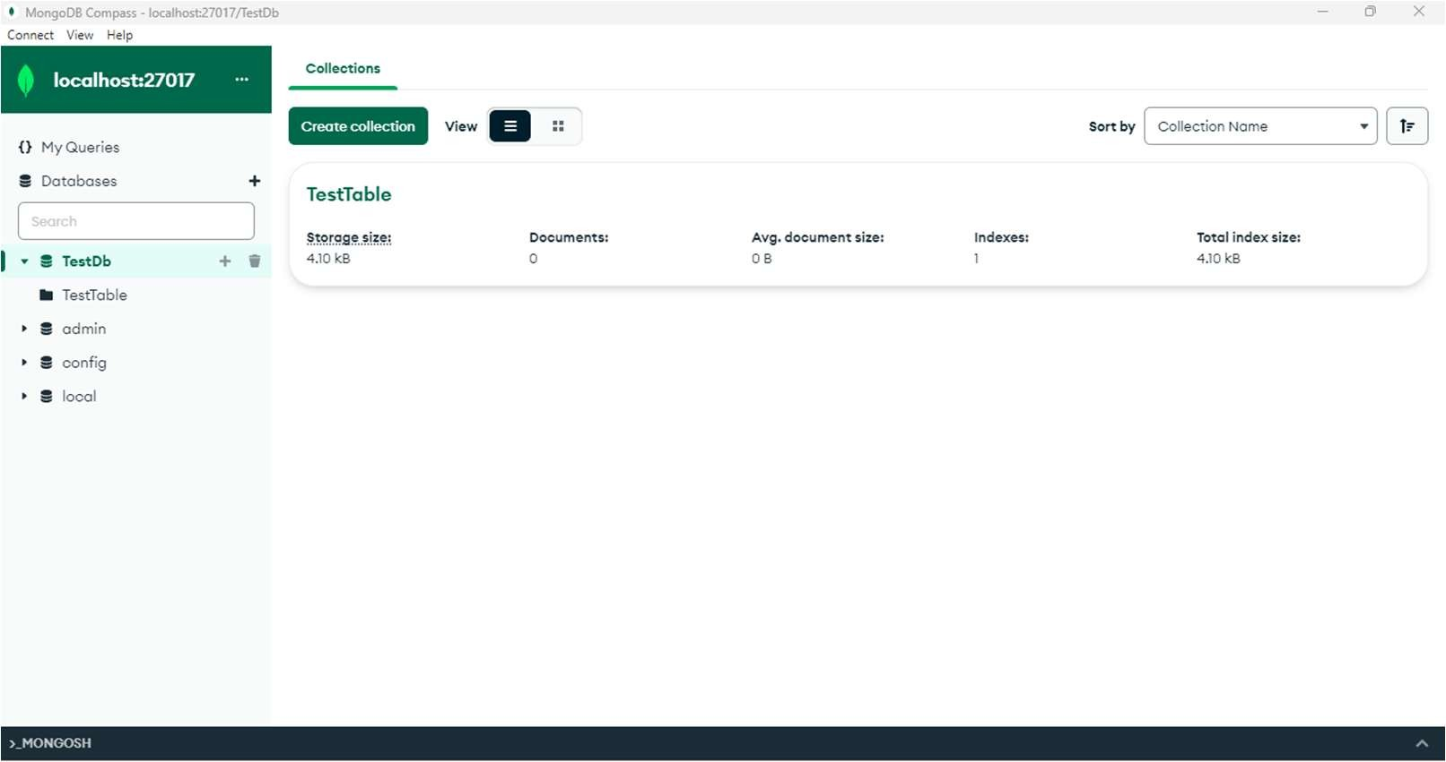

**Step 2 :** Select create database and then click on Add data and then choose Insert document.

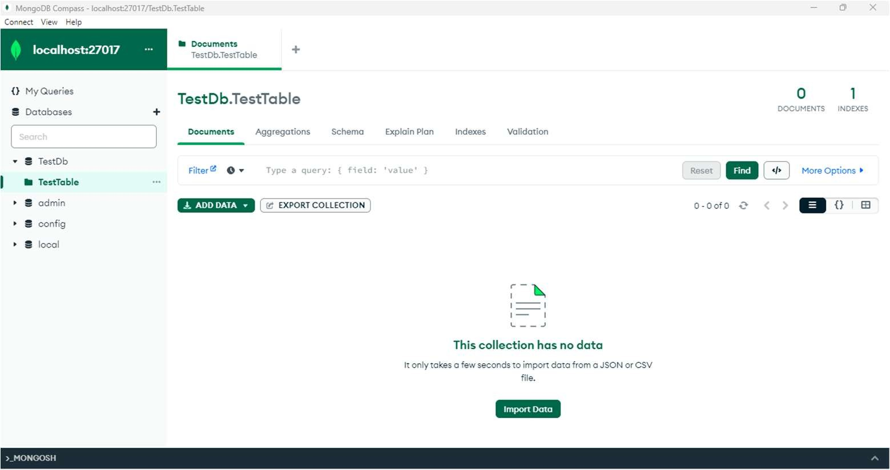

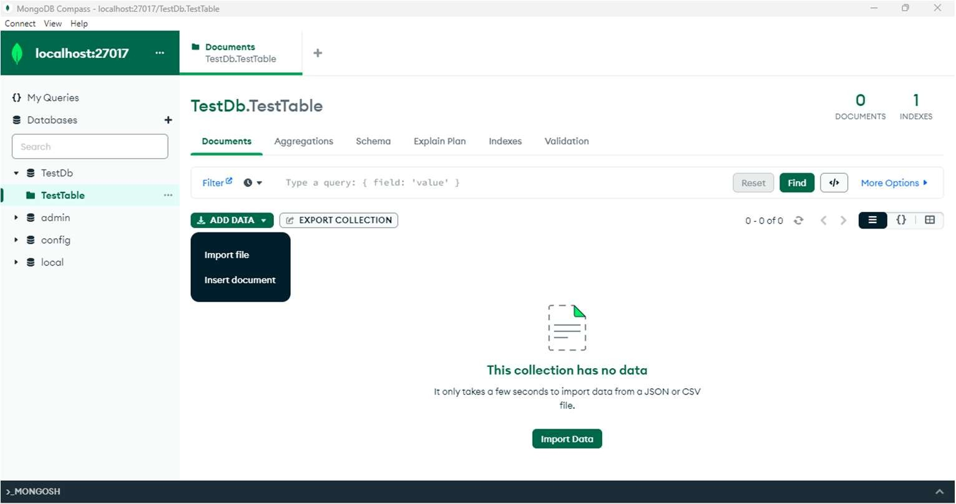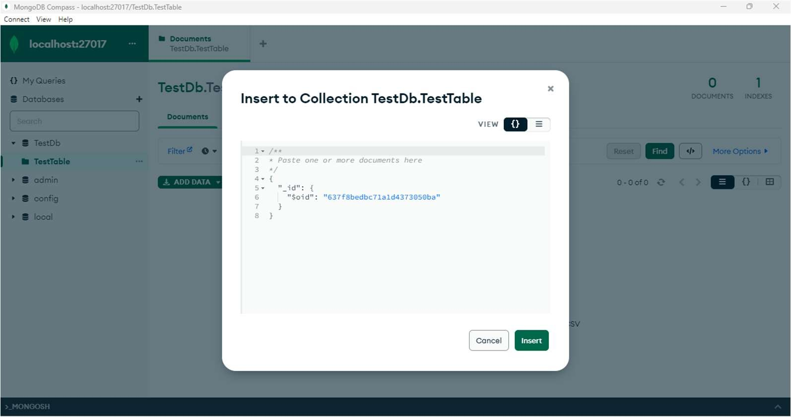

Insert data like name, age, status etc.

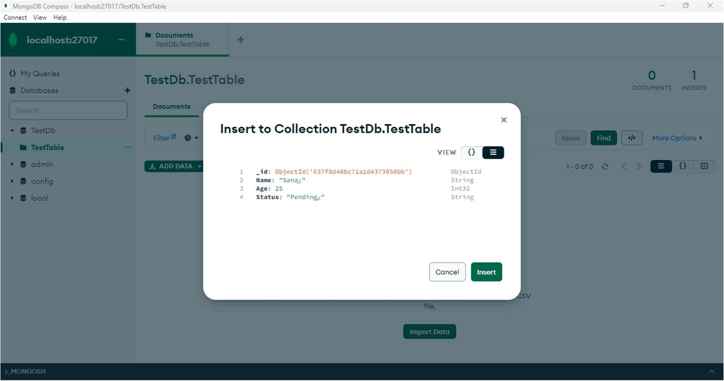

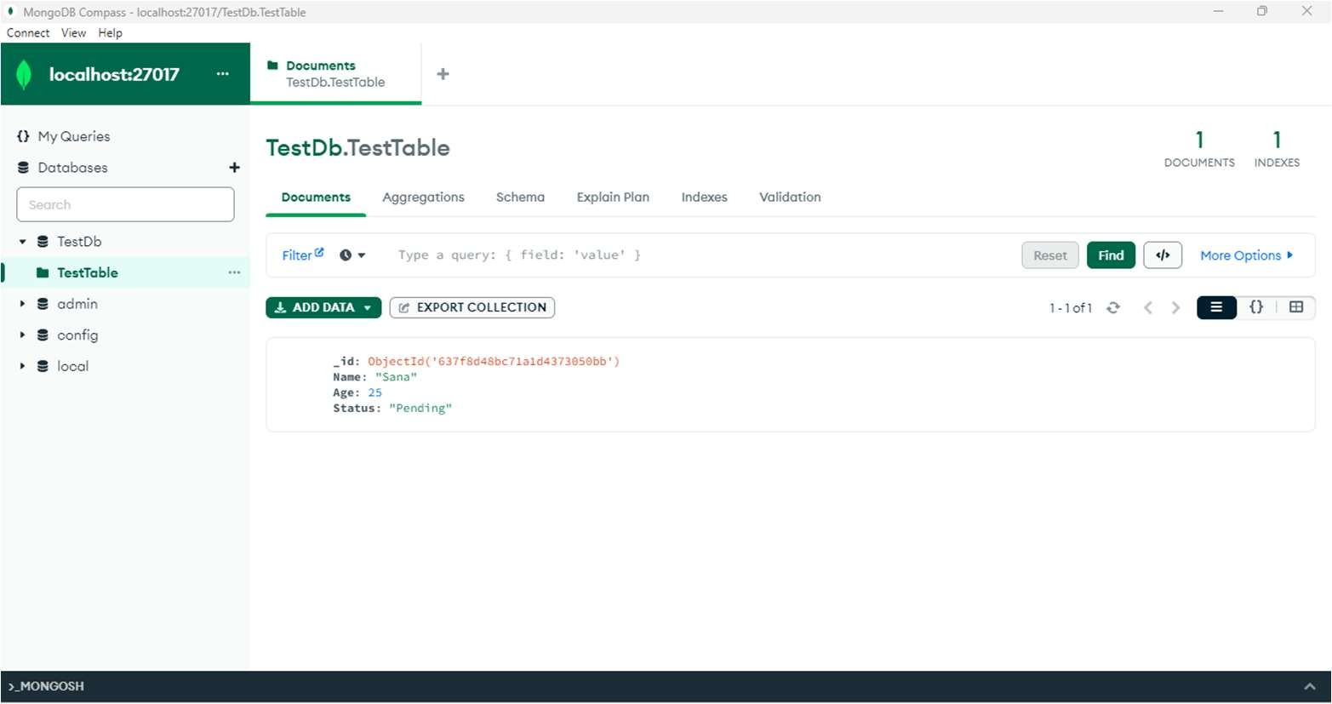

**Step 3** : You can add new data and update it.

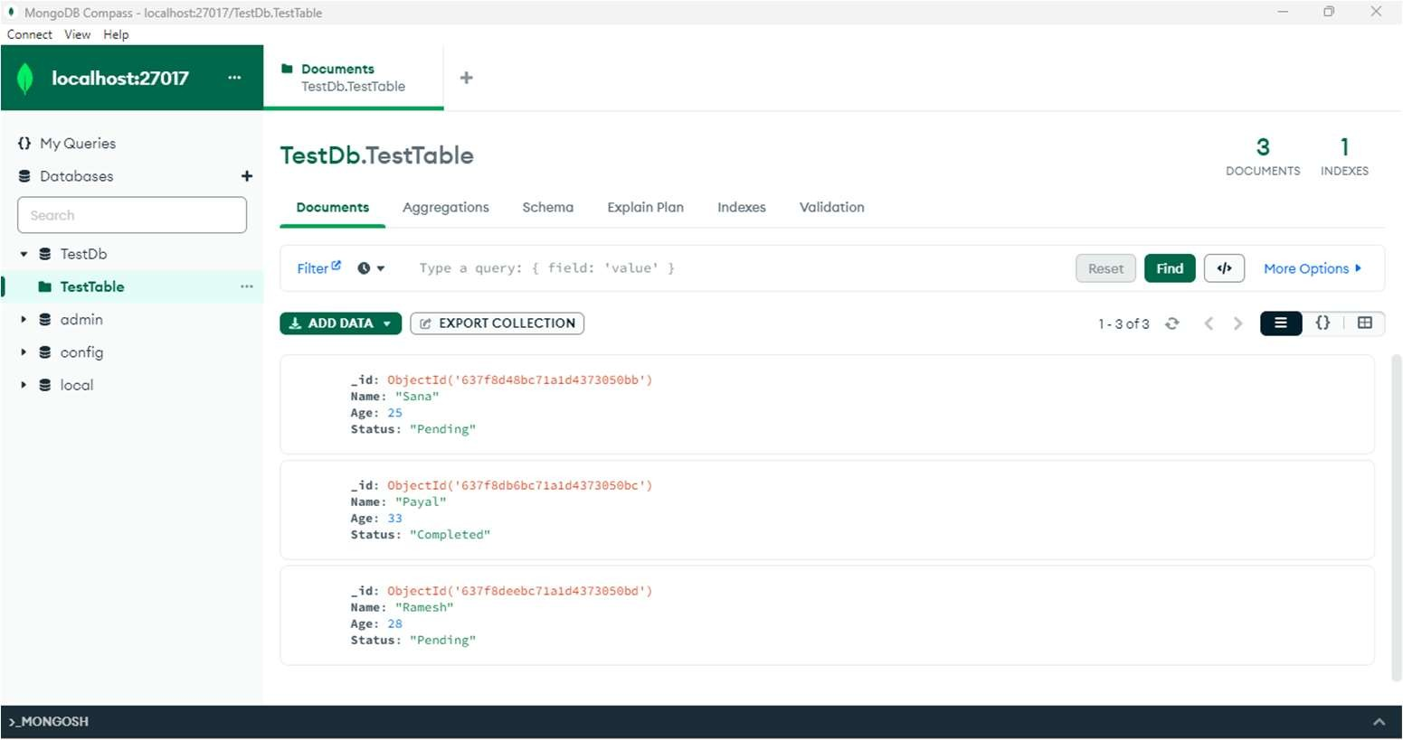

**Step 4** : We can see access data by mentioning its values or names in Filter menu.

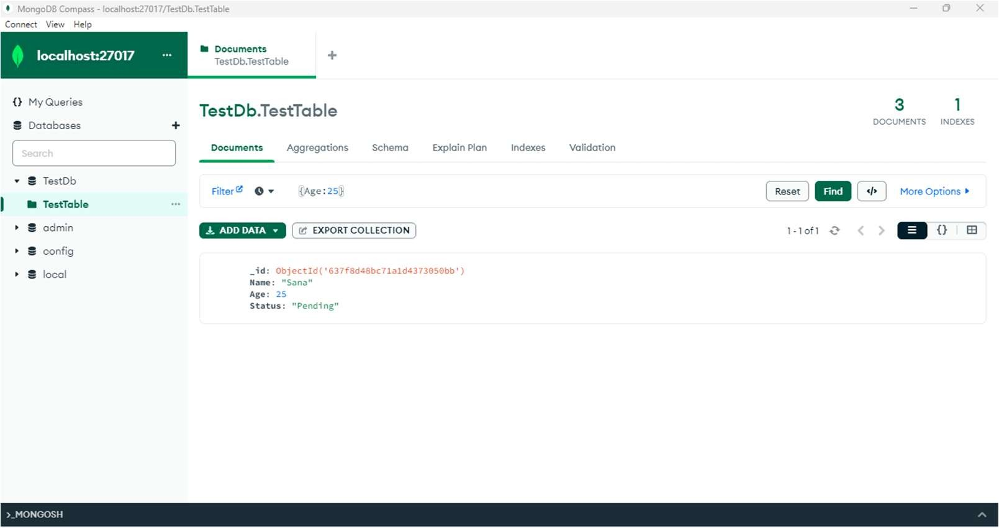

**Step 5** : To delete data, click on remove document.

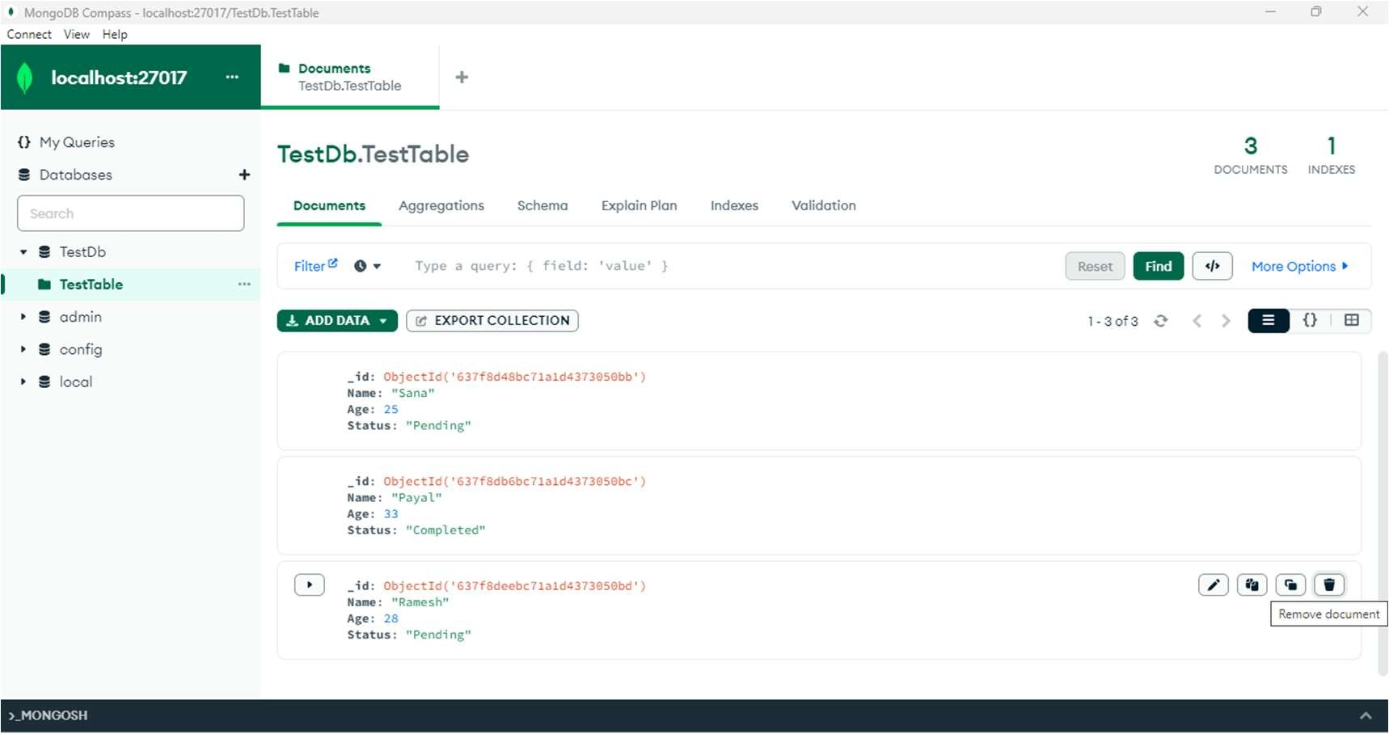

The updated database will look like :

